

**A CRM Application to Manage the Services offered by an Institution**

College: 7155 - PSG Institute of Technology and Applied Research

Team ID: NM2024TMID00683

Team Lead: Sarvesh S M (62A3A318B92E46184814F45BBA0F1DC1)

Team Members:

|  |  |
| --- | --- |
| DEEPTHI T S | F167471BC69797AB1704F09688902362 |
| RIYAAYINI S V | 66473A87418ACFF9D544921A99312532 |
| SARVESH S M | 62A3A318B92E46184814F45BBA0F1DC1 |
| SHREENA S | 38585984209AC37A2434007A73E93A3F |
| VISALI V S | 8EBC389C096B7D6B9FE4F6295B8516F7 |

**PROJECT OVERVIEW**

EduConsultPro Institute is a leading educational institution offering a variety of courses and programs in diverse fields. With a growing number of prospective students seeking admission each year, the institute faces challenges in managing the admission process, students enquiry, and expert consulting services efficiently. To address these challenges, EduConsultPro Institute decides to leverage Salesforce CRM to streamline the admission process and enhance the overall experience for both students and admissions staff.

The use case focuses on the admission process for prospective students interested in enrolling in courses and programs offered by EduConsultPro Institute. The goal is to provide a seamless and transparent experience for students while enabling admissions staff to efficiently review and process admission applications, students enquiry and case management.

**OBJECTIVES**

1. **Centralized CRM for Service Management:** Develop a Salesforce CRM application to manage EduConsultPro's core services, including student admissions, course management, and consulting services.
2. **Structured Data and Relationships:** Create custom objects and establish relationships among them to represent the institute’s data structure, such as courses, students, and admissions.
3. **Automated Admission Process:** Implement a screen flow to automate the student admission application process, guiding prospective students through each step efficiently.
4. **Appointment Booking for Existing Students:** Design a screen flow for existing students to book consulting appointments, enhancing support services through streamlined scheduling.
5. **Email Automation and Notifications:** Set up email templates and automated actions to notify students about their admission status and appointments, improving communication.
6. **Approval Workflow Configuration:** Create an approval process to facilitate administrative reviews and approvals for critical records, ensuring efficient decision-making.
7. **Comprehensive Flow Integration:** Combine all individual flows into a single unified flow, providing admissions staff with an accessible, one-stop interface for managing applications, inquiries, and appointments.
8. **Enhanced User Interface with Lightning Apps:** Develop Lightning apps and pages to present a user-friendly interface for admissions staff, enhancing usability and productivity.

**SALESFORCE KEY FEATURES AND CONCEPTS UTILIZED**

**Custom Objects and Data Modeling**

* **Objects Creation:** Custom objects were created to represent key entities like Courses, Students, and Admissions, directly from a spreadsheet for ease of setup.
* **Relationship Building:** Relationships were established among objects (such as lookups and master-detail relationships) to reflect the data structure of EduConsultPro and allow for interconnected data across records.

**Standard Objects Configuration**

* **Case Object:** Configured the Case object to manage student inquiries, allowing support staff to log, track, and resolve inquiries efficiently.
* **User Object and Permissions:** Configured user roles, profiles, and permissions to control access and ensure that admissions staff can view and update only relevant data.

**Process Automation with Flows**

* **Screen Flow for Admission Process:** Designed a step-by-step screen flow to guide prospective students through the admission application process, including data collection, decision points, and record creation.
* **Flow for Appointment Booking:** Developed a screen flow for existing students to book appointments for consulting services, automating the scheduling process.
* **Record-Triggered Flow:** Configured a record-triggered flow to automate actions (like sending notifications) based on specific changes in record status, enhancing responsiveness.
* **SubFlows and Combined Flow:** Integrated multiple flows into a single, comprehensive flow to streamline admissions management in one place.

**Approval Processes**

* Created a multi-step approval process for critical records, such as admissions or consulting requests, ensuring administrative reviews and approval tracking for important decisions.

**Email Templates and Notification Automation**

* **Custom Email Templates:** Designed email templates for admission status updates and appointment confirmations.
* **Automated Notifications:** Configured automated emails and in-app notifications, keeping students informed about their application status and appointments.

**Lightning App and App Pages**

* **Lightning App Creation:** Developed a dedicated Lightning app for admissions, providing staff with quick access to essential functions.
* **Custom Lightning App Pages:** Created visually engaging and user-friendly Lightning pages for streamlined navigation and efficient data management.

**Dynamic User Interface Elements**

* **Screen Elements in Flows:** Incorporated screen elements for data entry, selection, and confirmation in flows, creating an interactive user experience.
* **Decision and Action Elements:** Utilized decision elements to guide flow paths based on conditions, and action elements to automate updates and notifications.

**DETAILED STEPS TO CREATE SOLUTIONS DESIGN**

**Create Objects from Spreadsheet**

1. Go to Object Manager and select Create Object from Spreadsheet to create the Course object.
2. Download the Course spreadsheet, upload it, map the fields, and create the object.
3. Follow the same steps to create the remaining objects: Consultant, Student, and Appointment.
4. Establish lookup relationships between Appointment and Student, and Appointment and Consultant.
5. Create a Registration object to store details about student course enrollments, linking Student and Course records.
6. Configure a lookup relationship between Student and Case to manage student queries related to immigration and visa applications.
7. Customize the Case object by adding values to the Type field (Immigration, Visa Application) and the Status field (Open, In-progress).
8. Create a new Lightning App called EduConsultPro, adding essential tabs like Home, Students, Courses, Consultants, Appointments, Registrations, and Cases.
9. Assign the System Administrator profile to the app to ensure proper access and functionality.

**Create Course Object:**

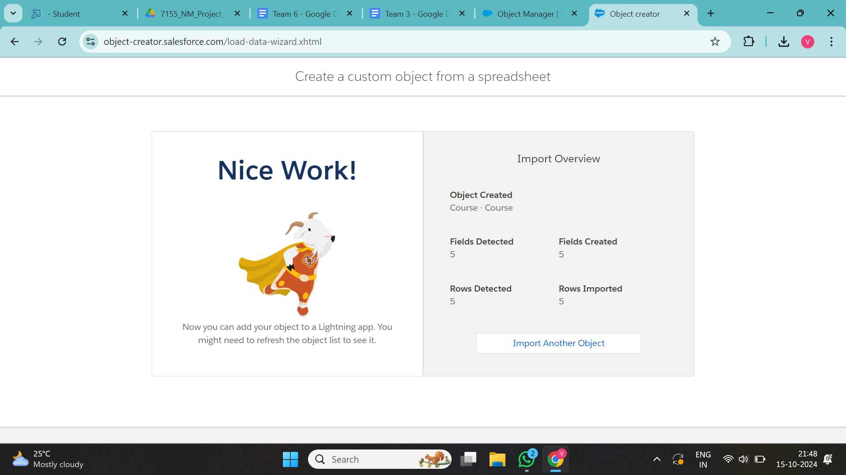

**Create Remaining Objects:**

1. **Consultant**

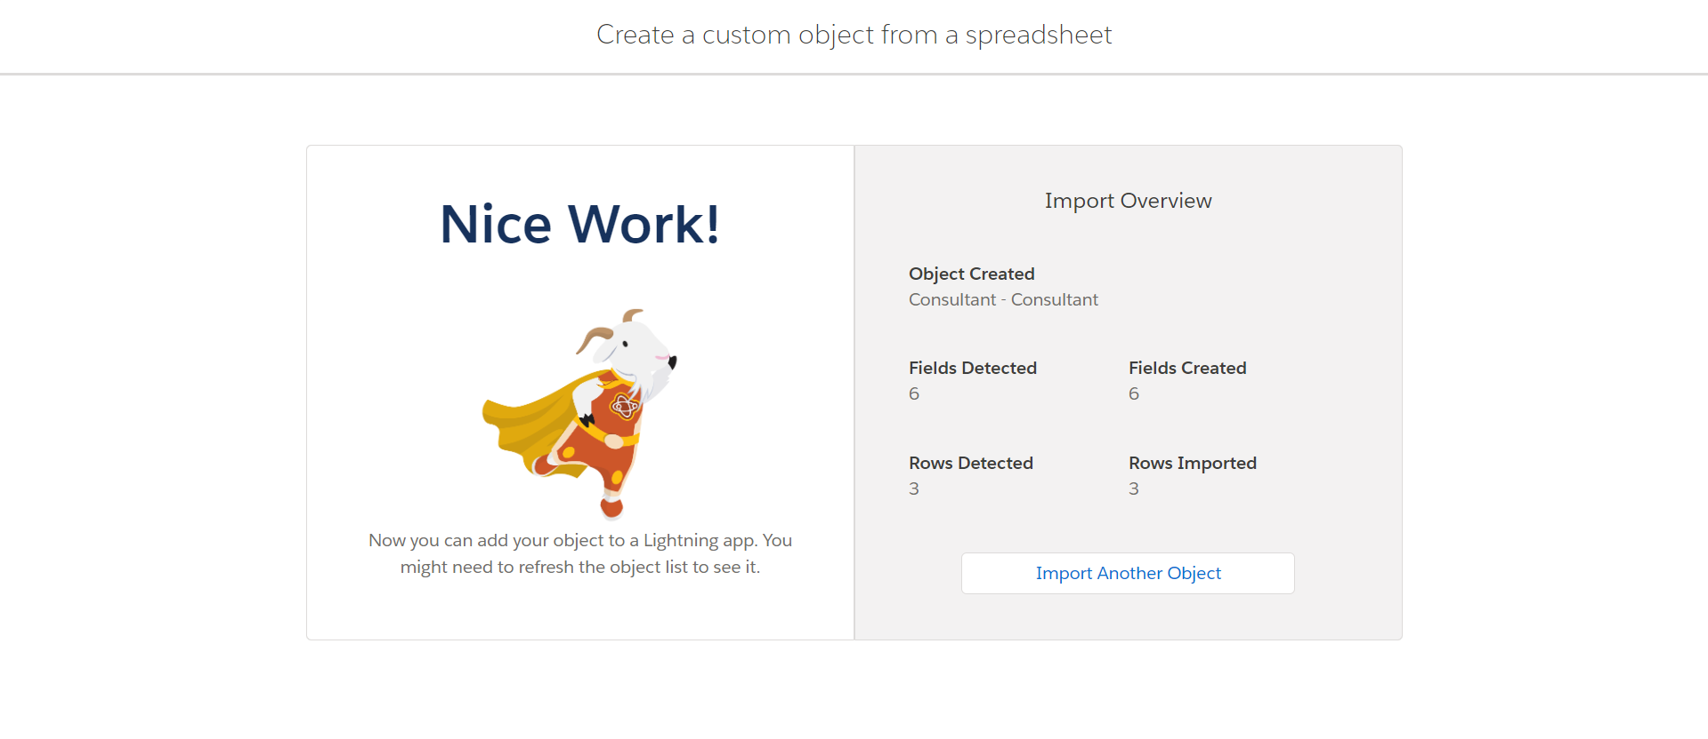

1. **Student**

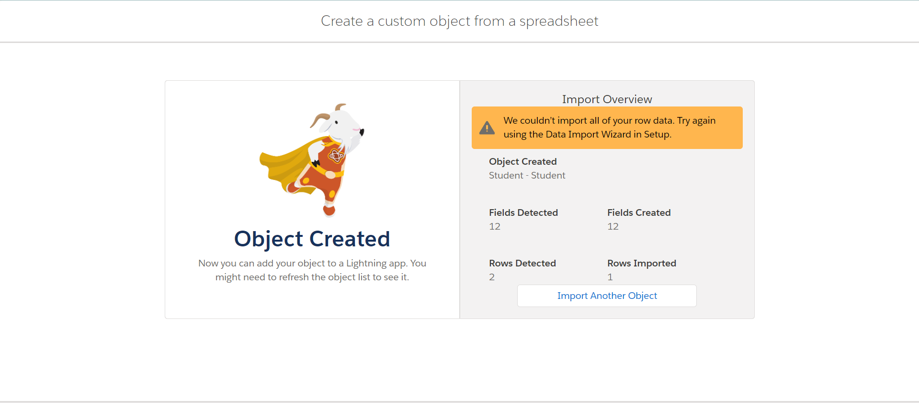

1. **Appointment**

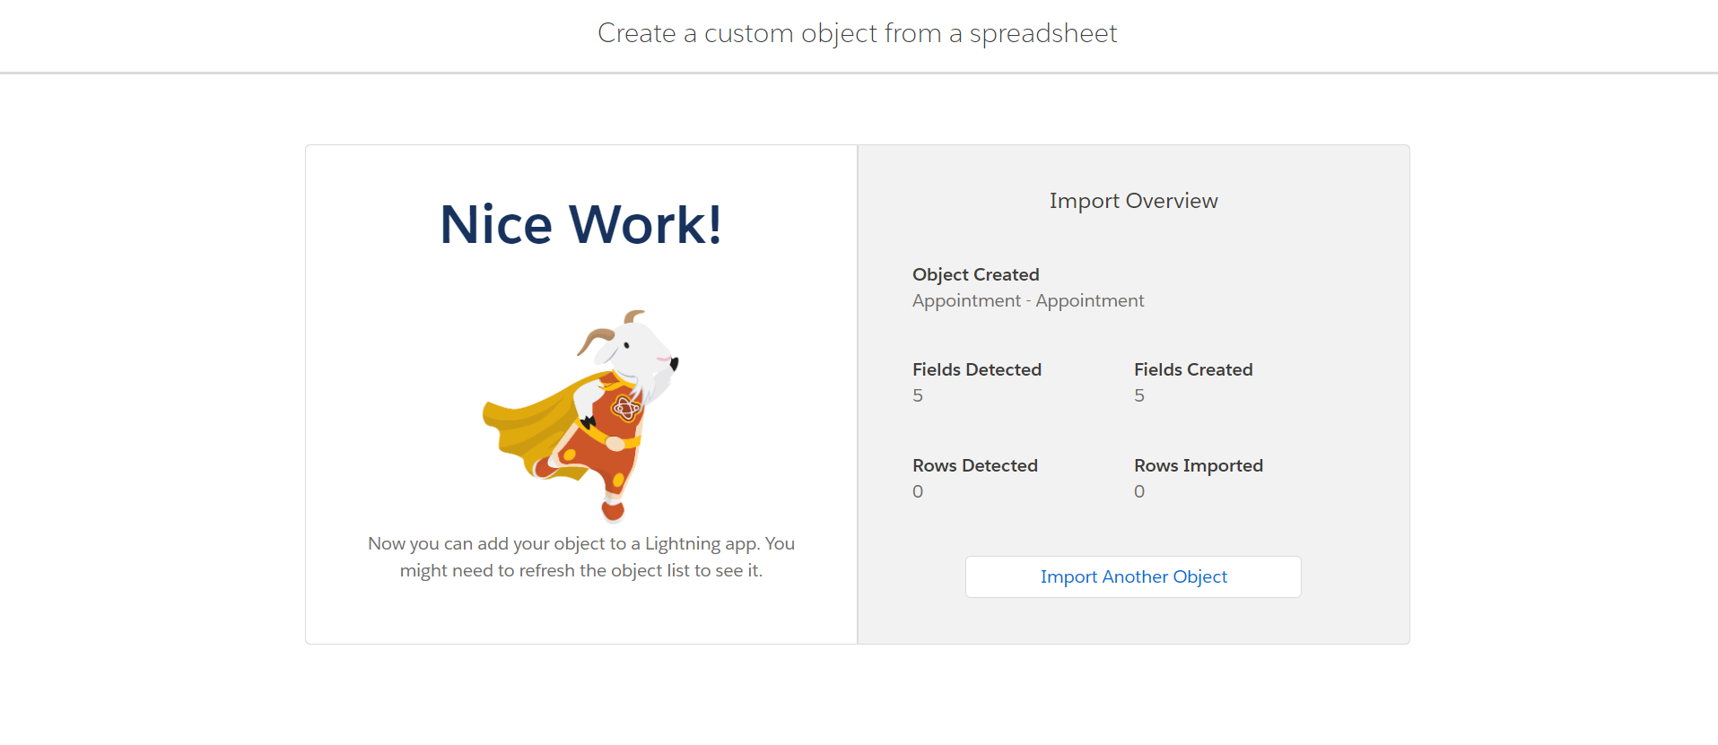**Create Relationships Among The Objects:**

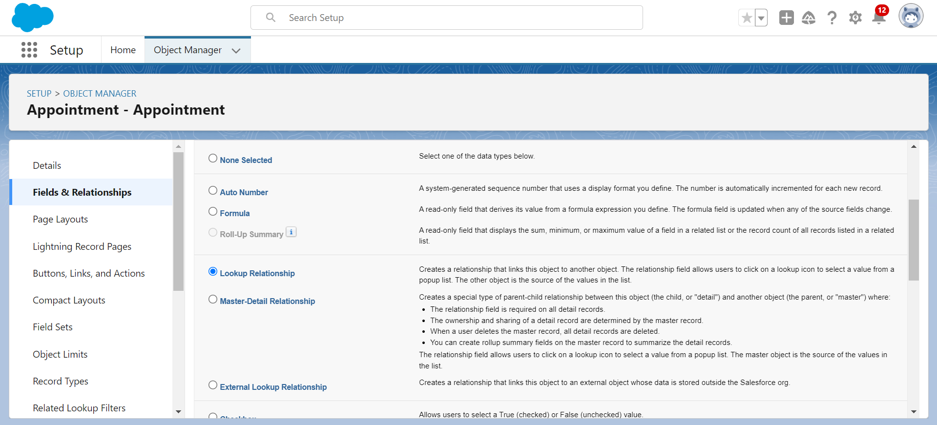

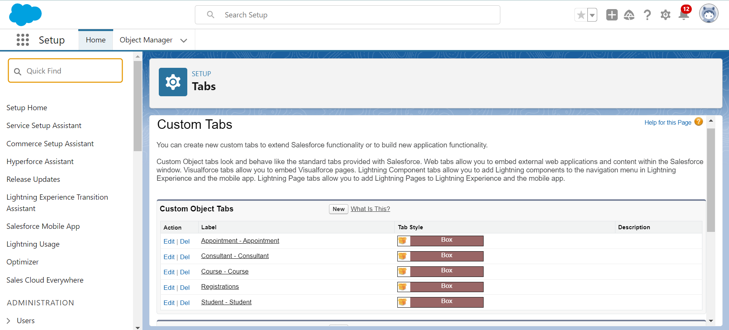

**Configure The Case Object:**

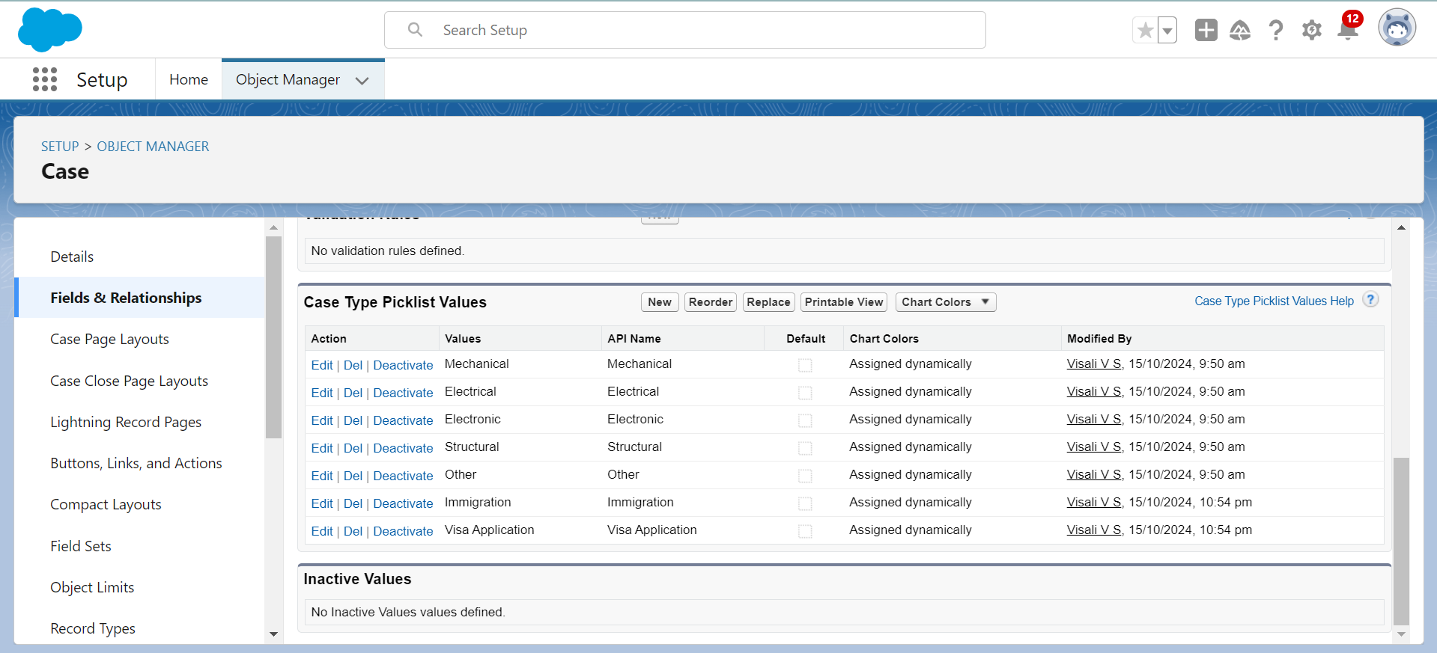

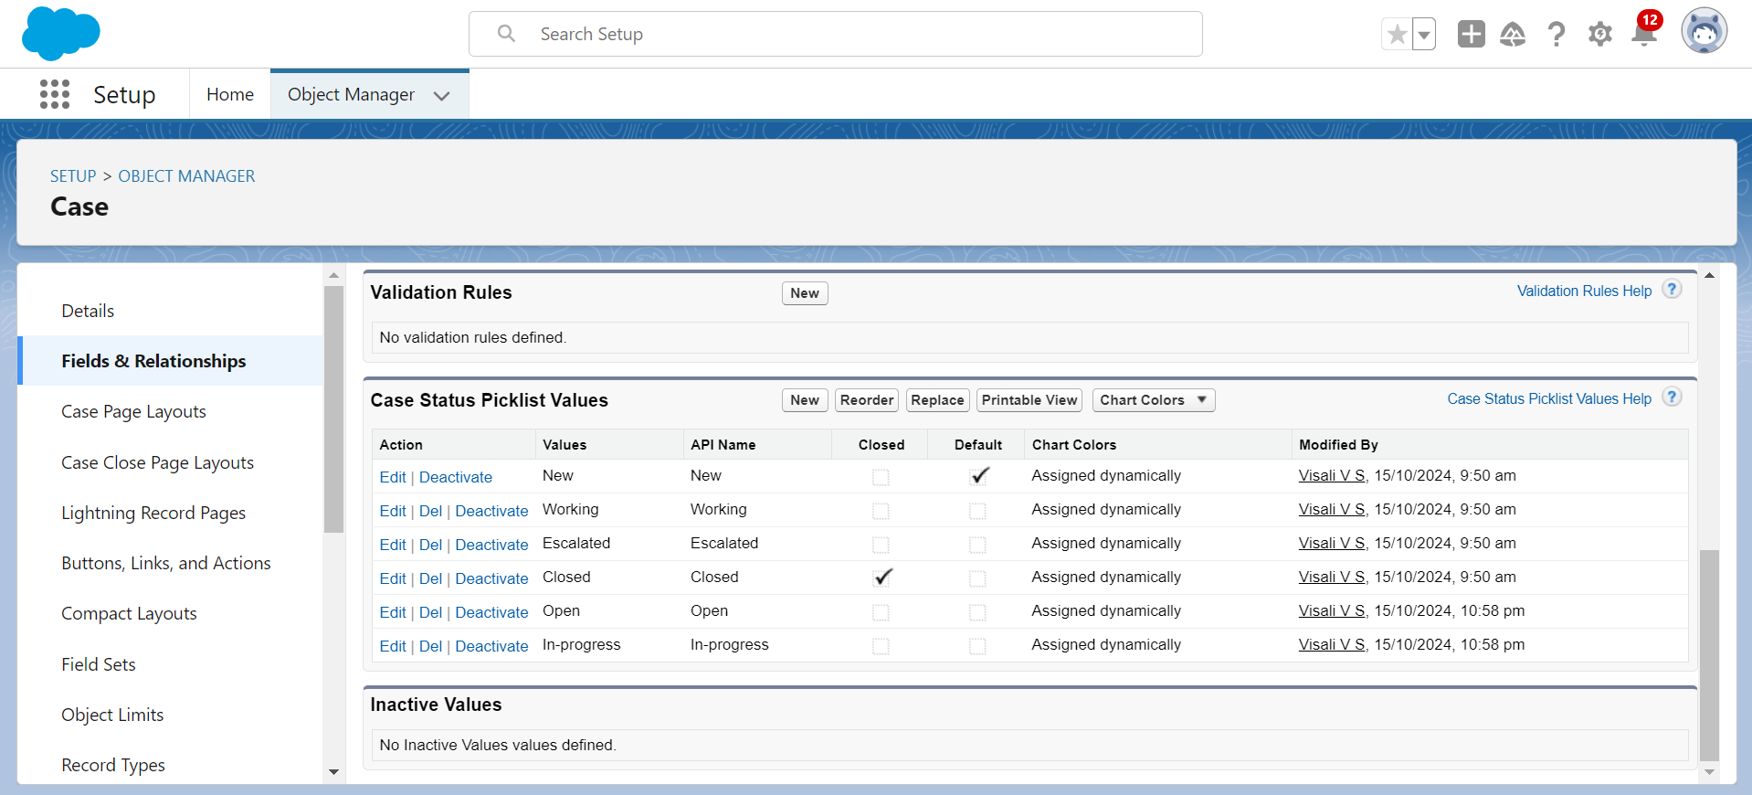

**Create A Lightning App**

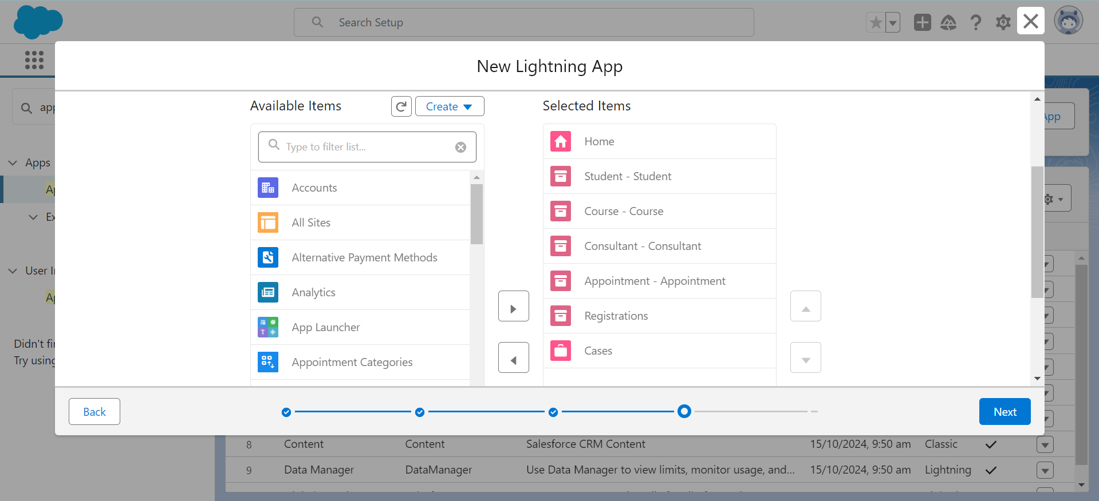

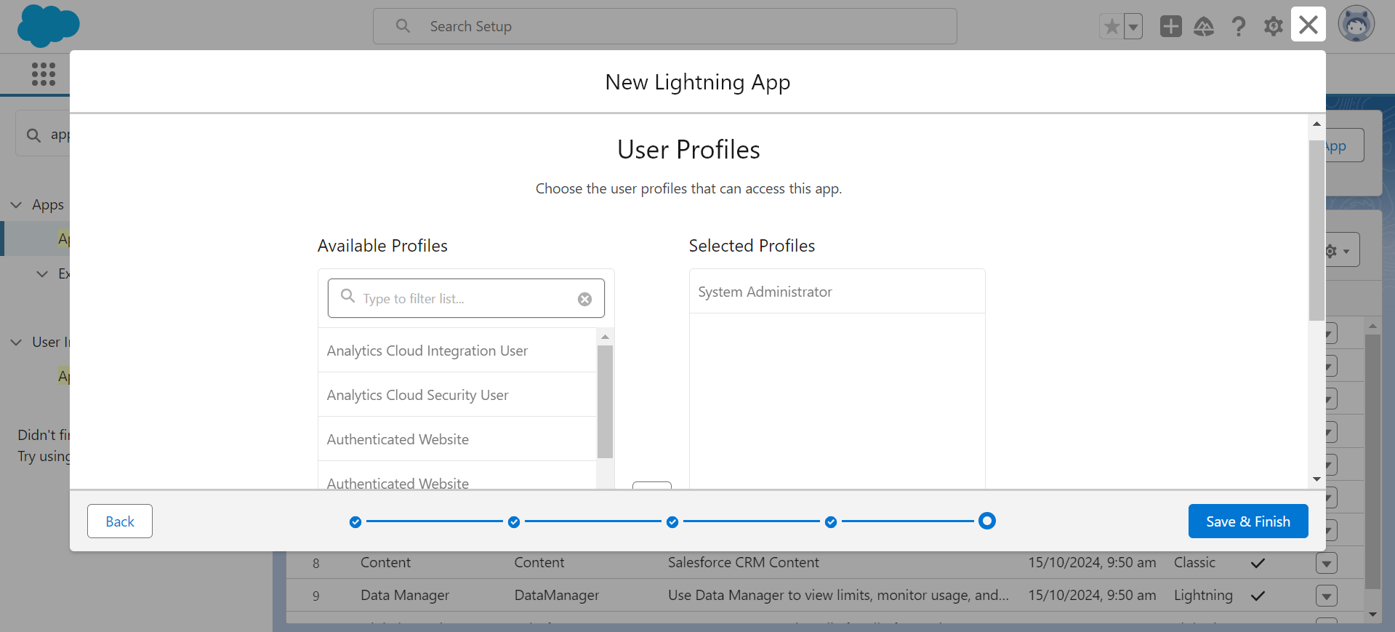

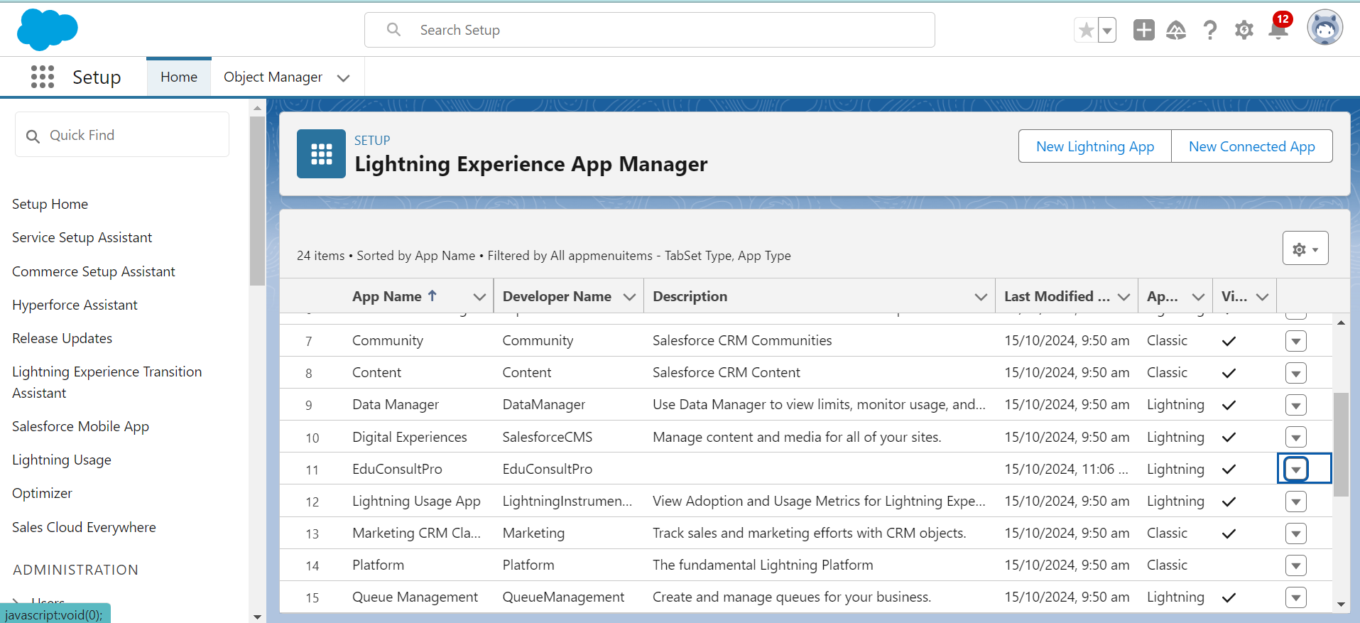

**Create a ScreenFlow for Student Admission Application process**

1. Create a ScreenFlow for the student admission application process.
2. Add a Screen Element to collect information from the student.
3. Use the Create Records element to create a new Student record.
4. Add another Screen Element to display confirmation or further instructions to the student.
5. Add a Decision Element to check conditions such as eligibility or form completeness.
6. Add a Get Records element to retrieve existing data, if necessary.
7. Use the Create Records element again to create a Registration record linking the student to the selected course.
8. Create Email Text Template Variables for the body and subject of the admission confirmation email.
9. Add an Action Element to send the email to the student.
10. Add another Screen Element to display a final confirmation or thank you message to the student.

**Add Screen Element**

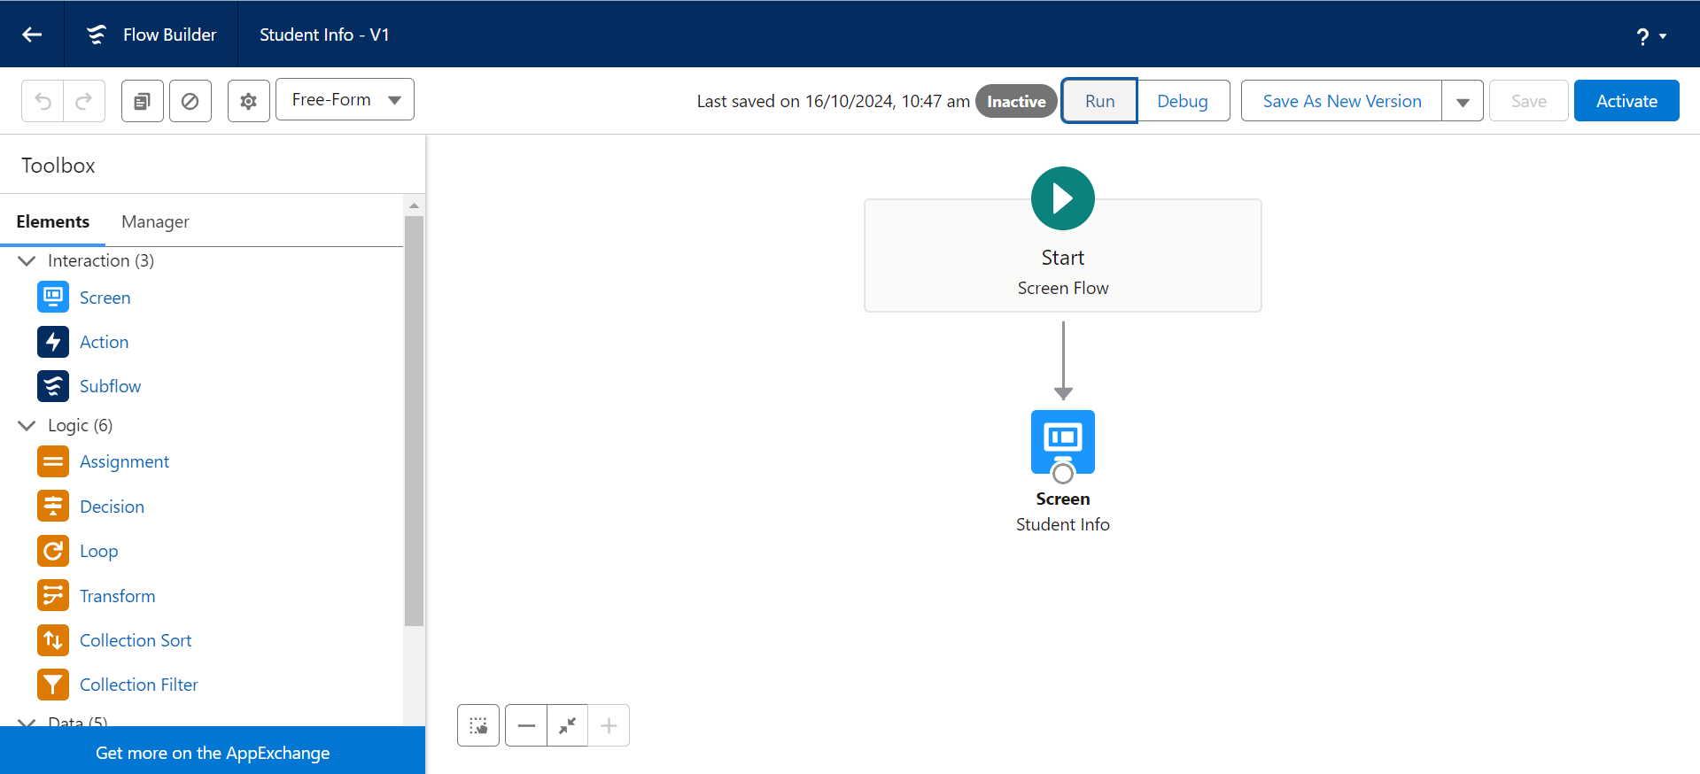

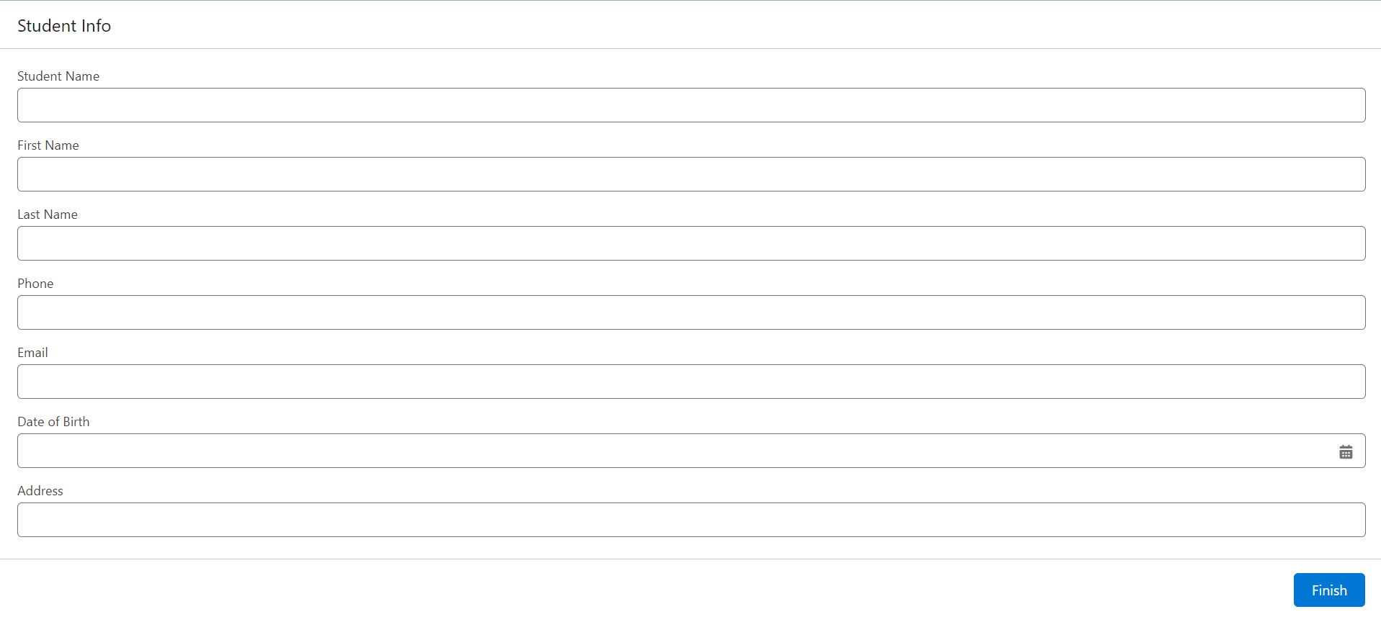**Create Student Record using Create Element:**

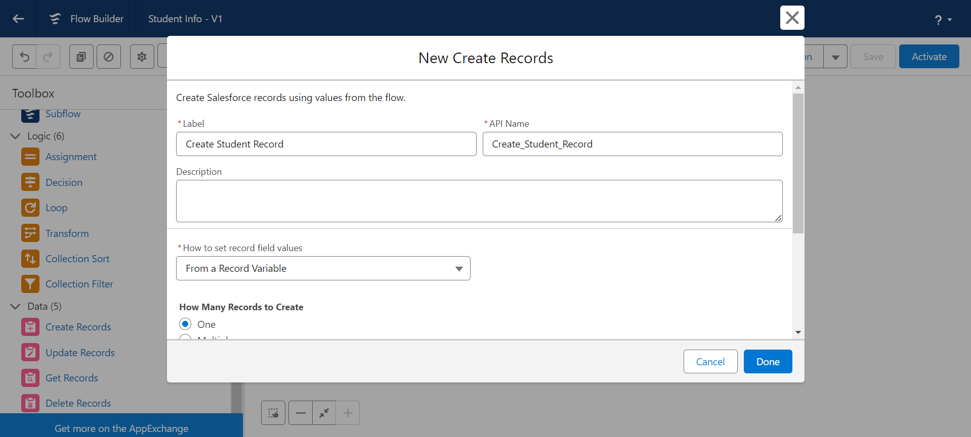

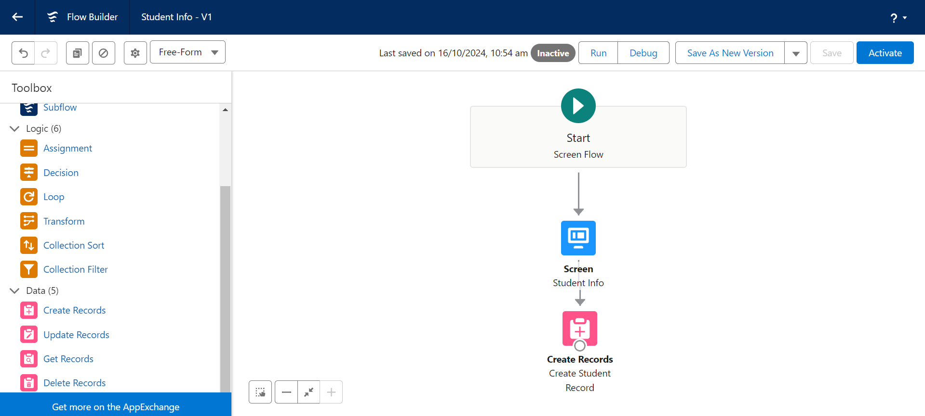

**Add Screen Element:**

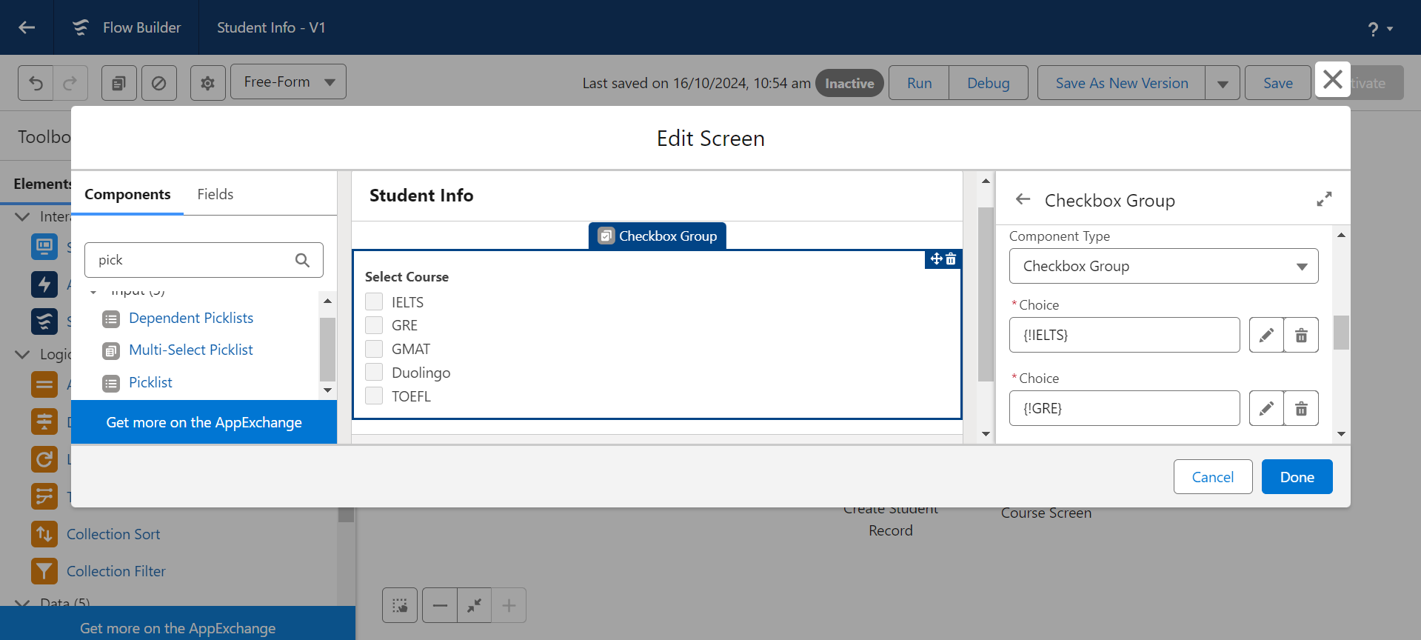

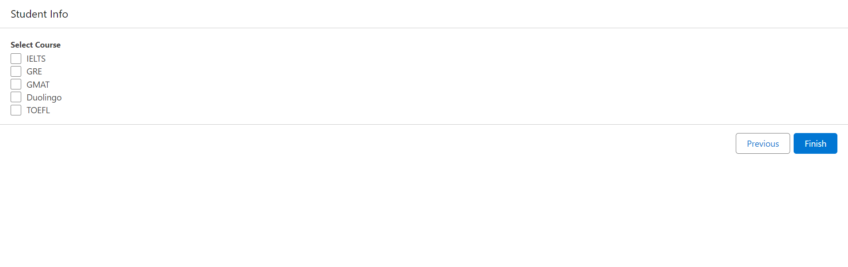

**Add Decision Element:**

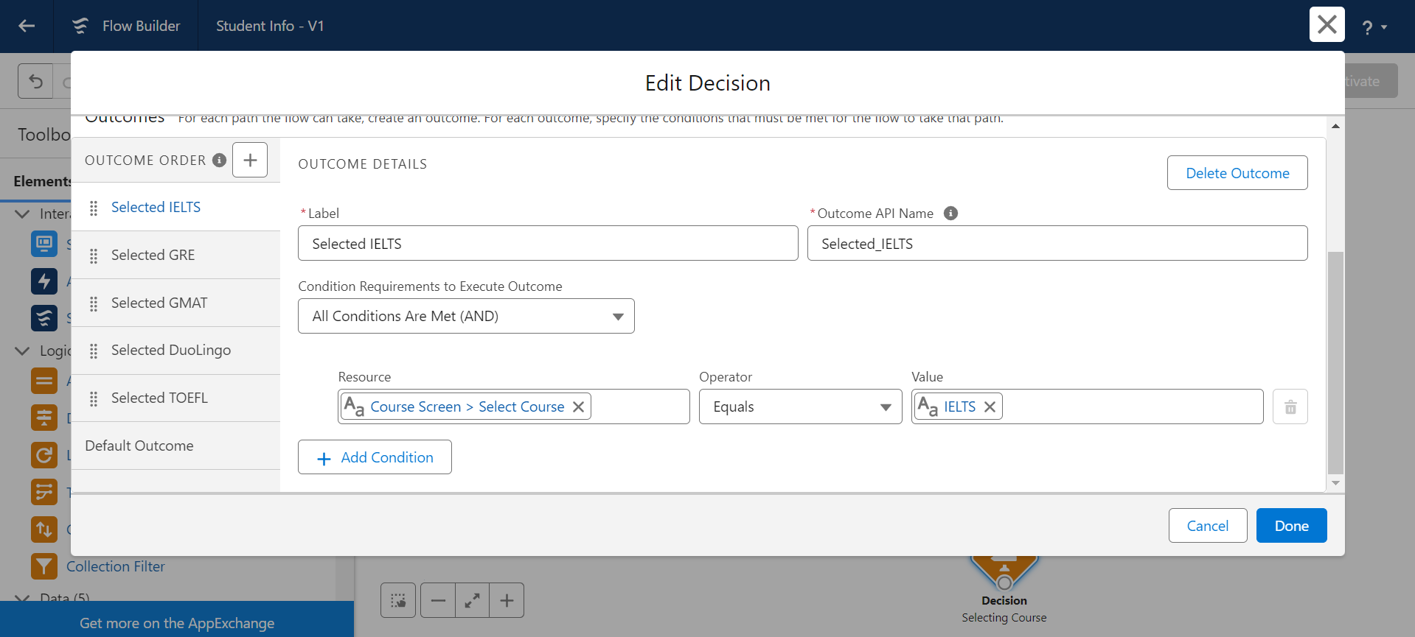

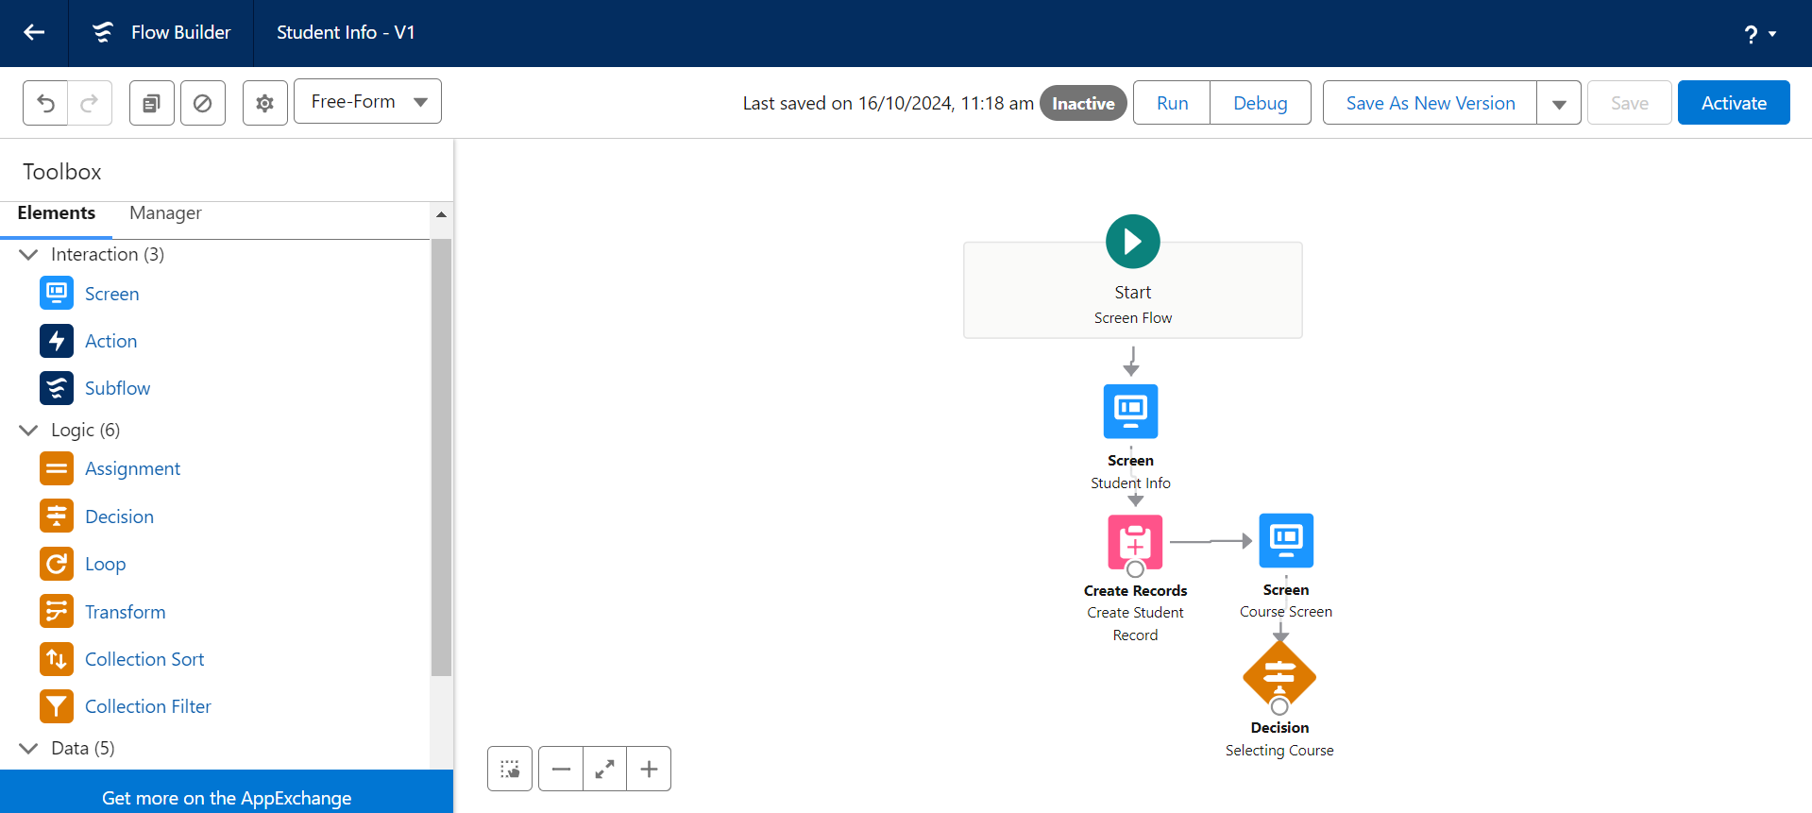

**Add GET Record Element:**

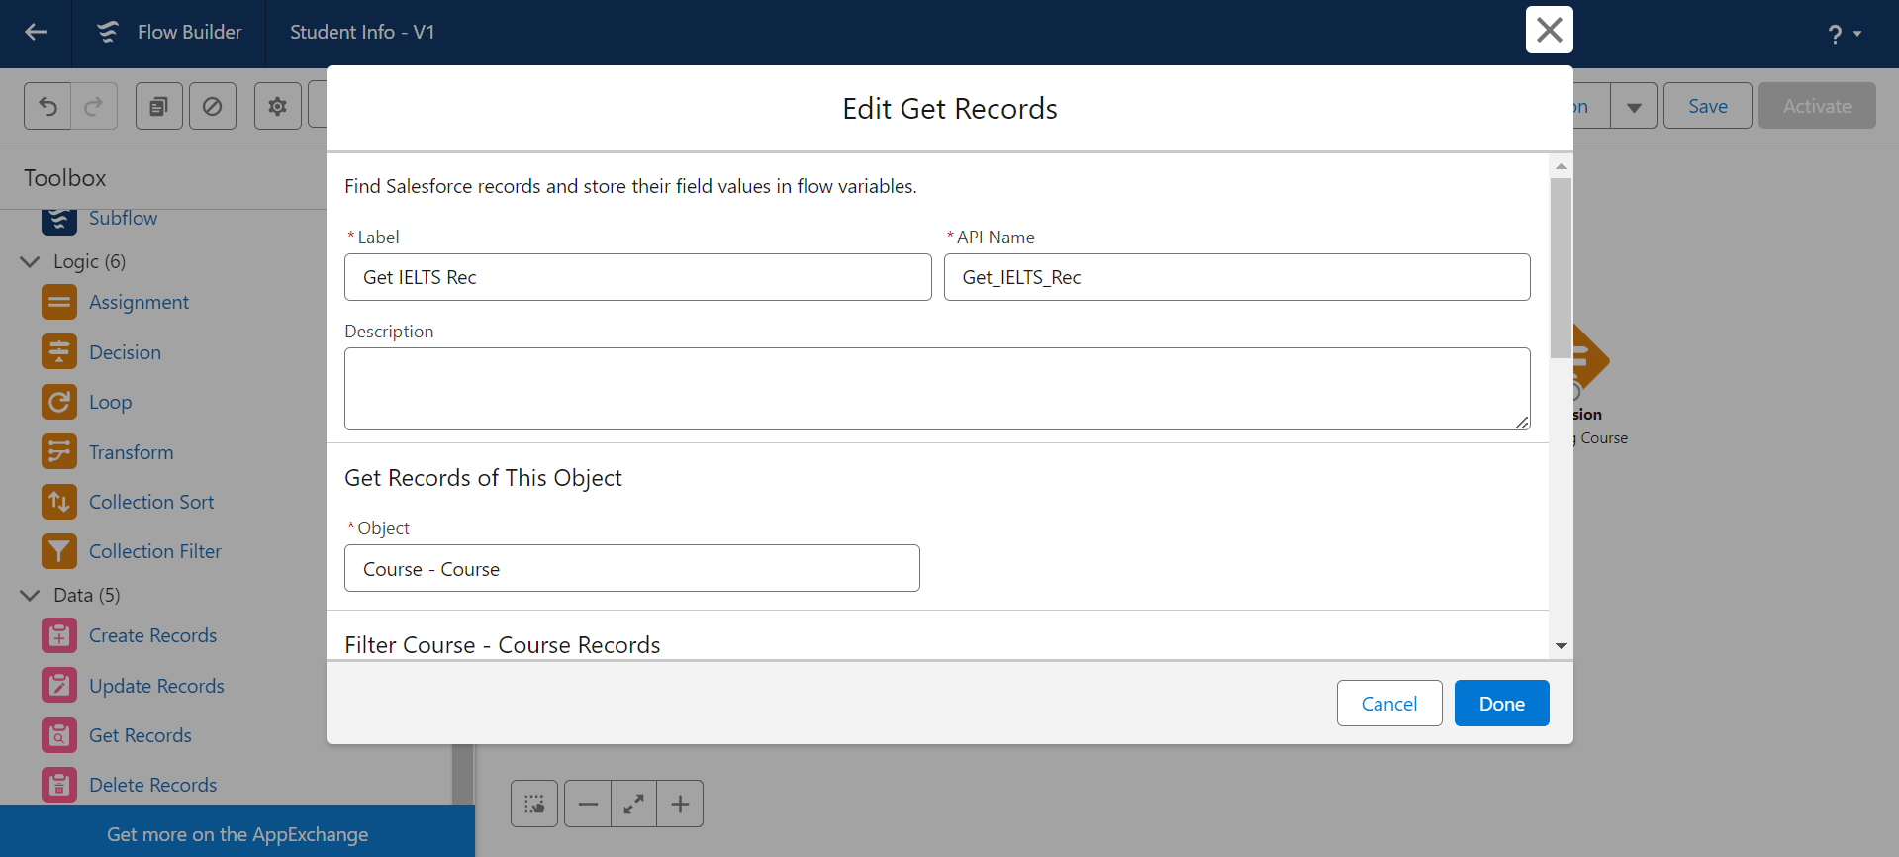

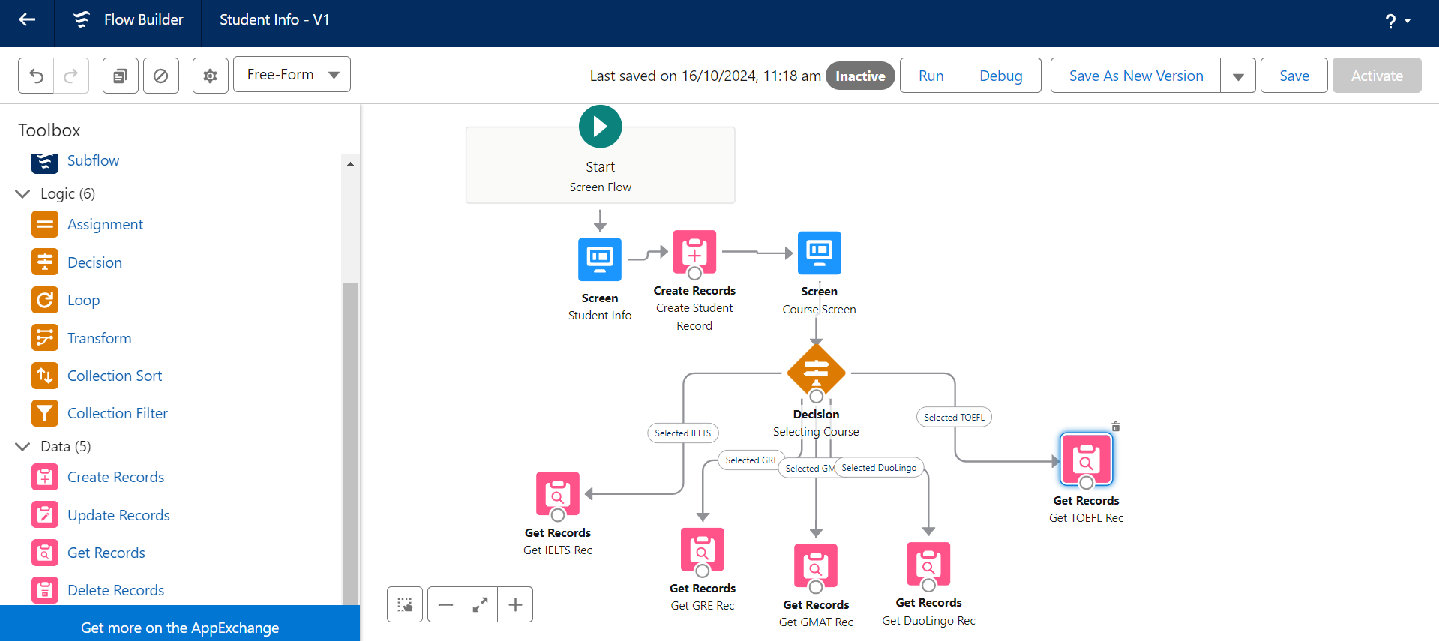

**Create Registration Record using Create Records Element:**

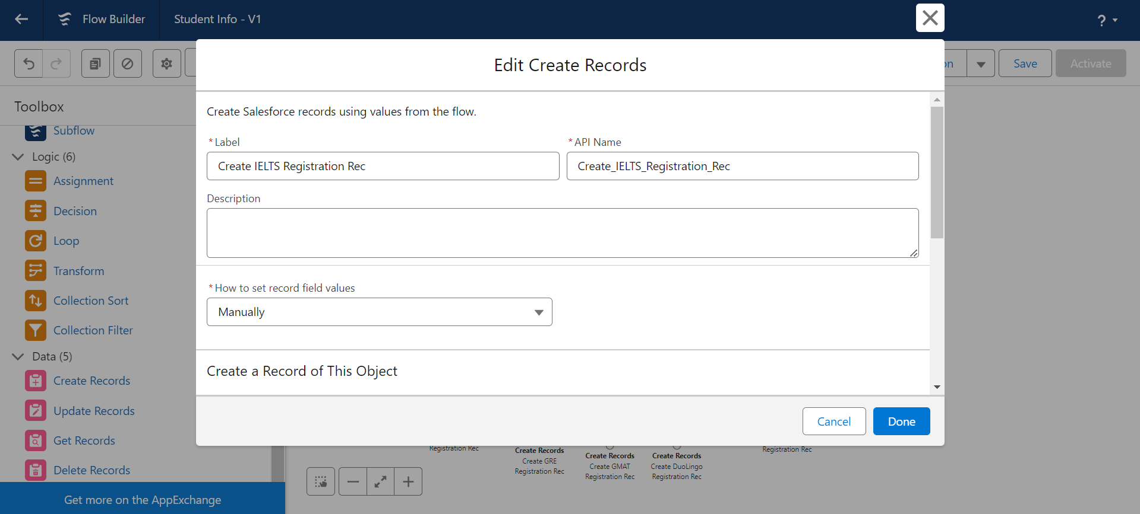

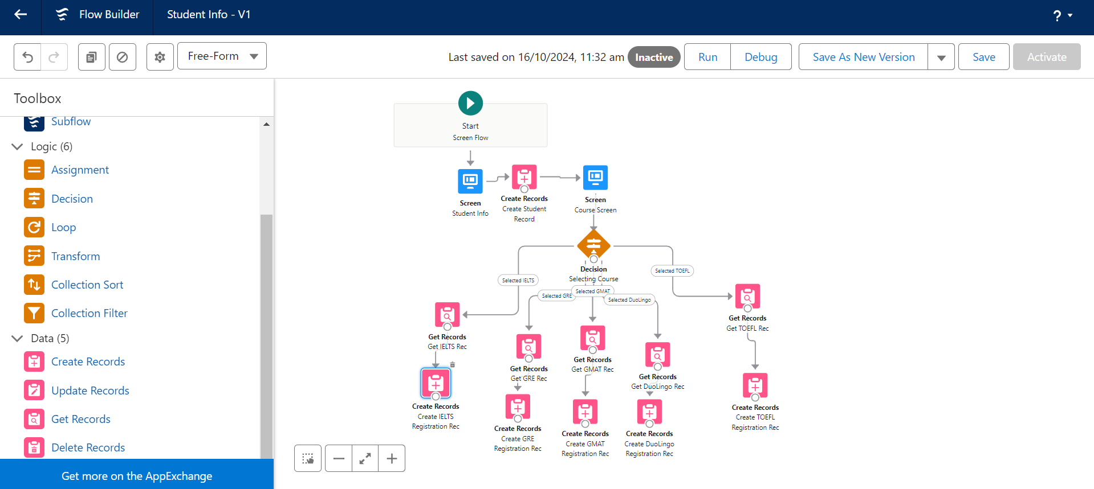

**Create Email Text Template Variables For Email Body And Subject:**

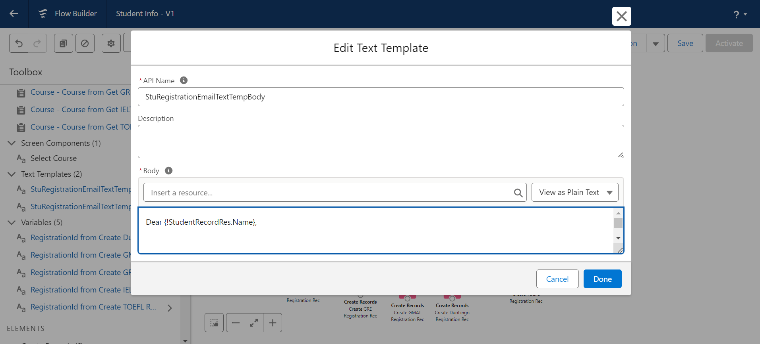

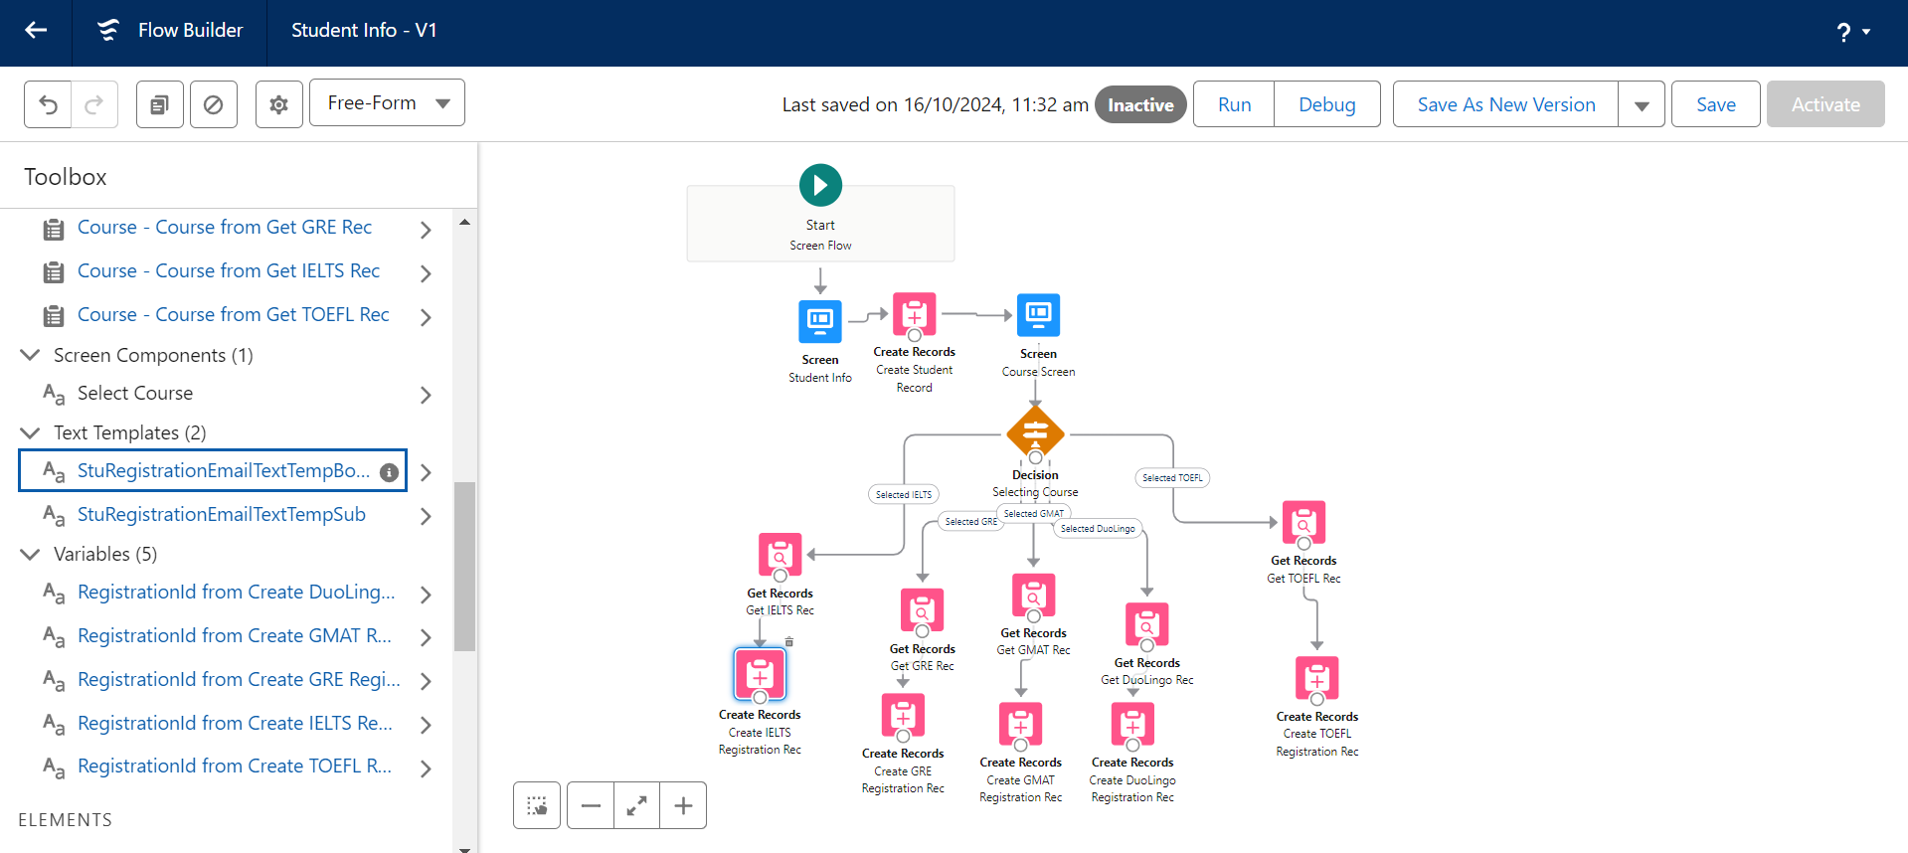

**Add An Action Element**

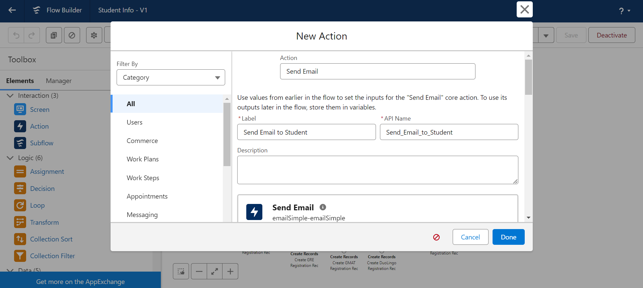

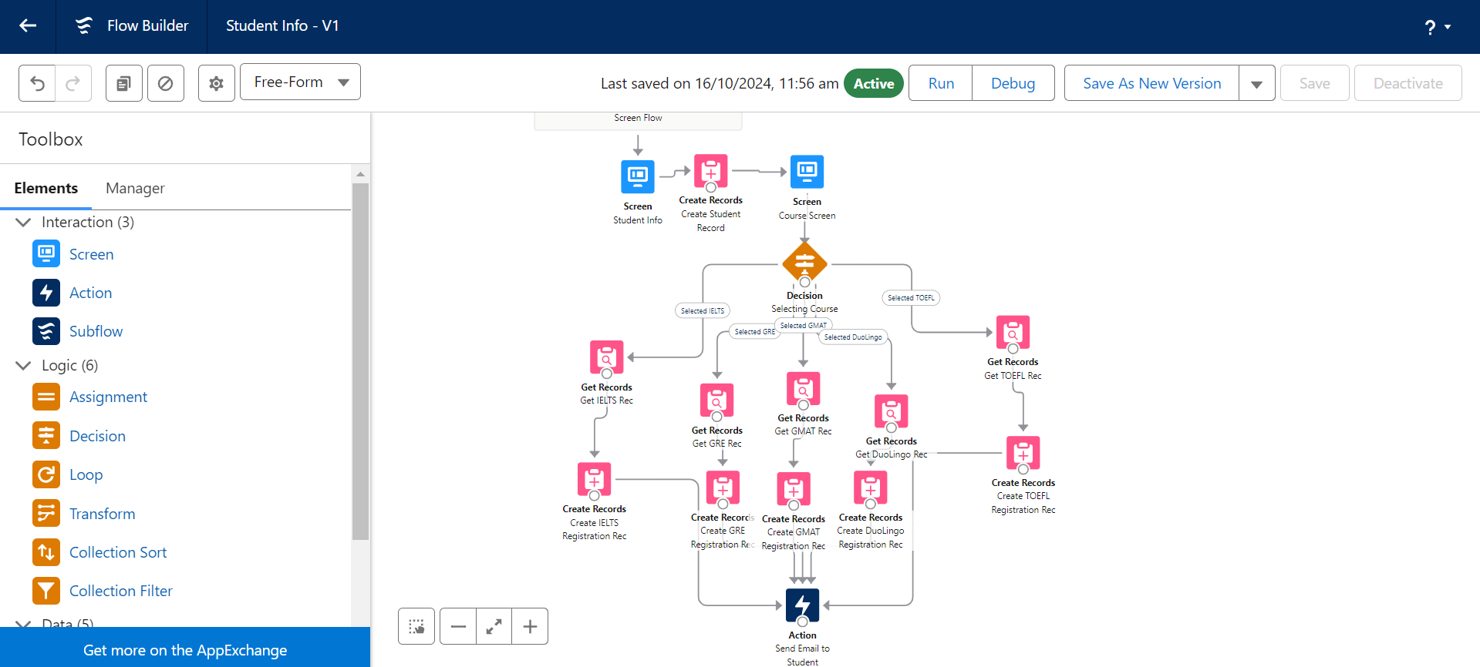

**Add Screen Element:**

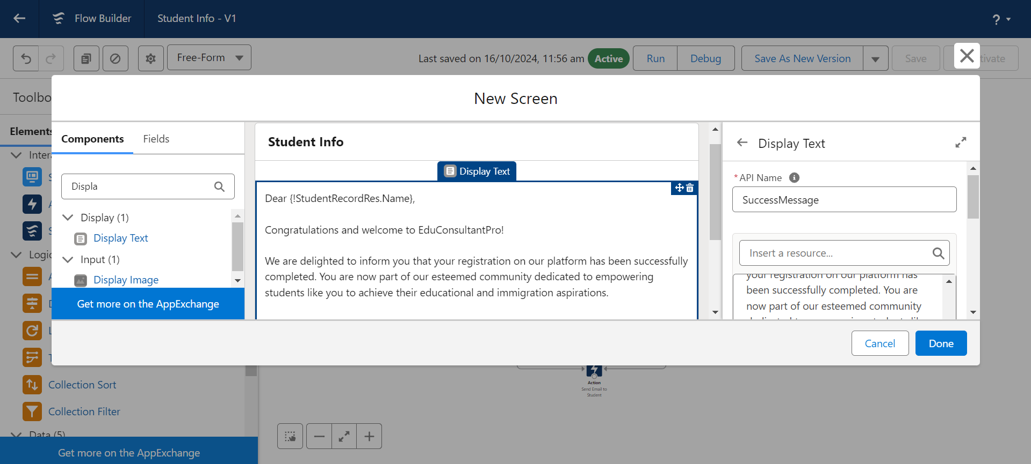

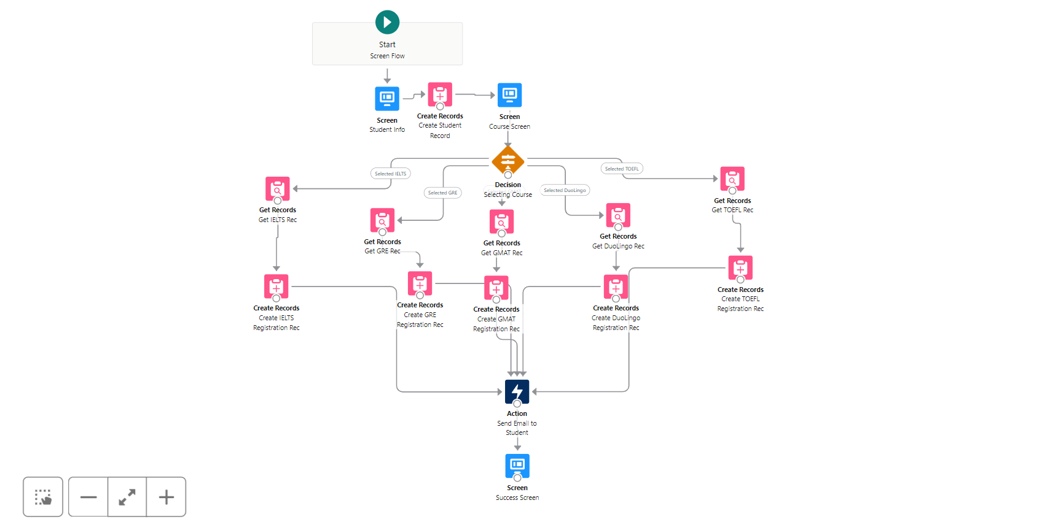

**Create Users**

1. Create new Users by navigating to the User section in Salesforce and adding the required user details such as name, profile, and role.
2. Configure User Settings by assigning appropriate profiles and roles to ensure users have the necessary access and permissions to perform their tasks effectively.

**User:**

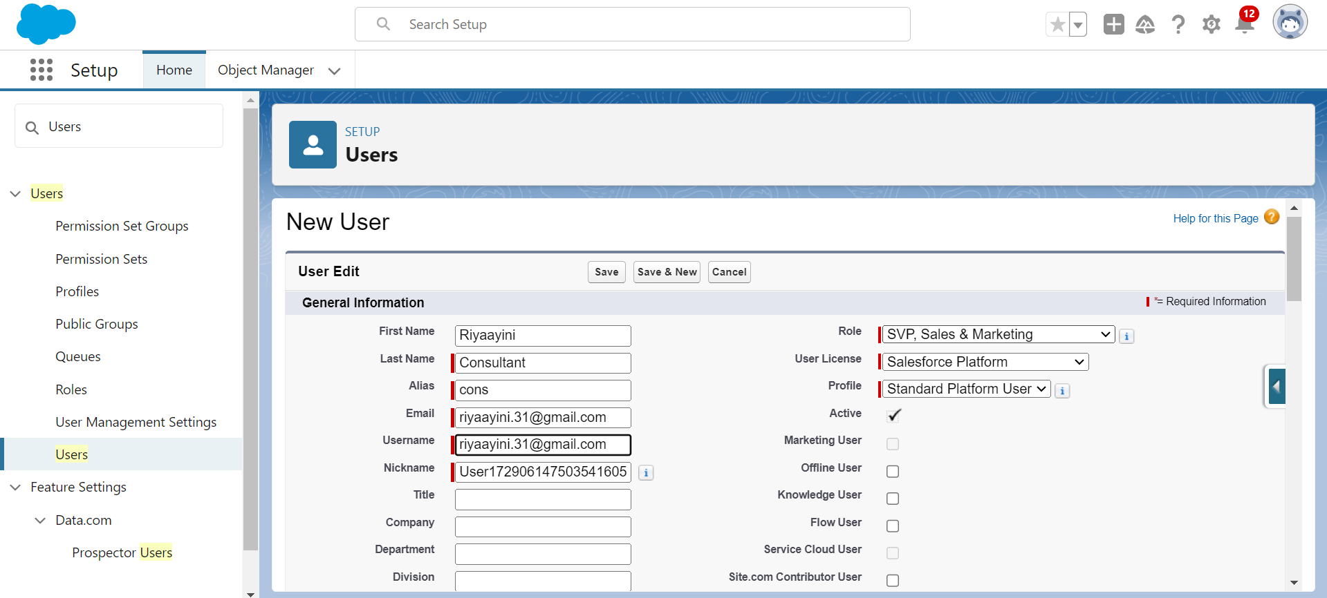

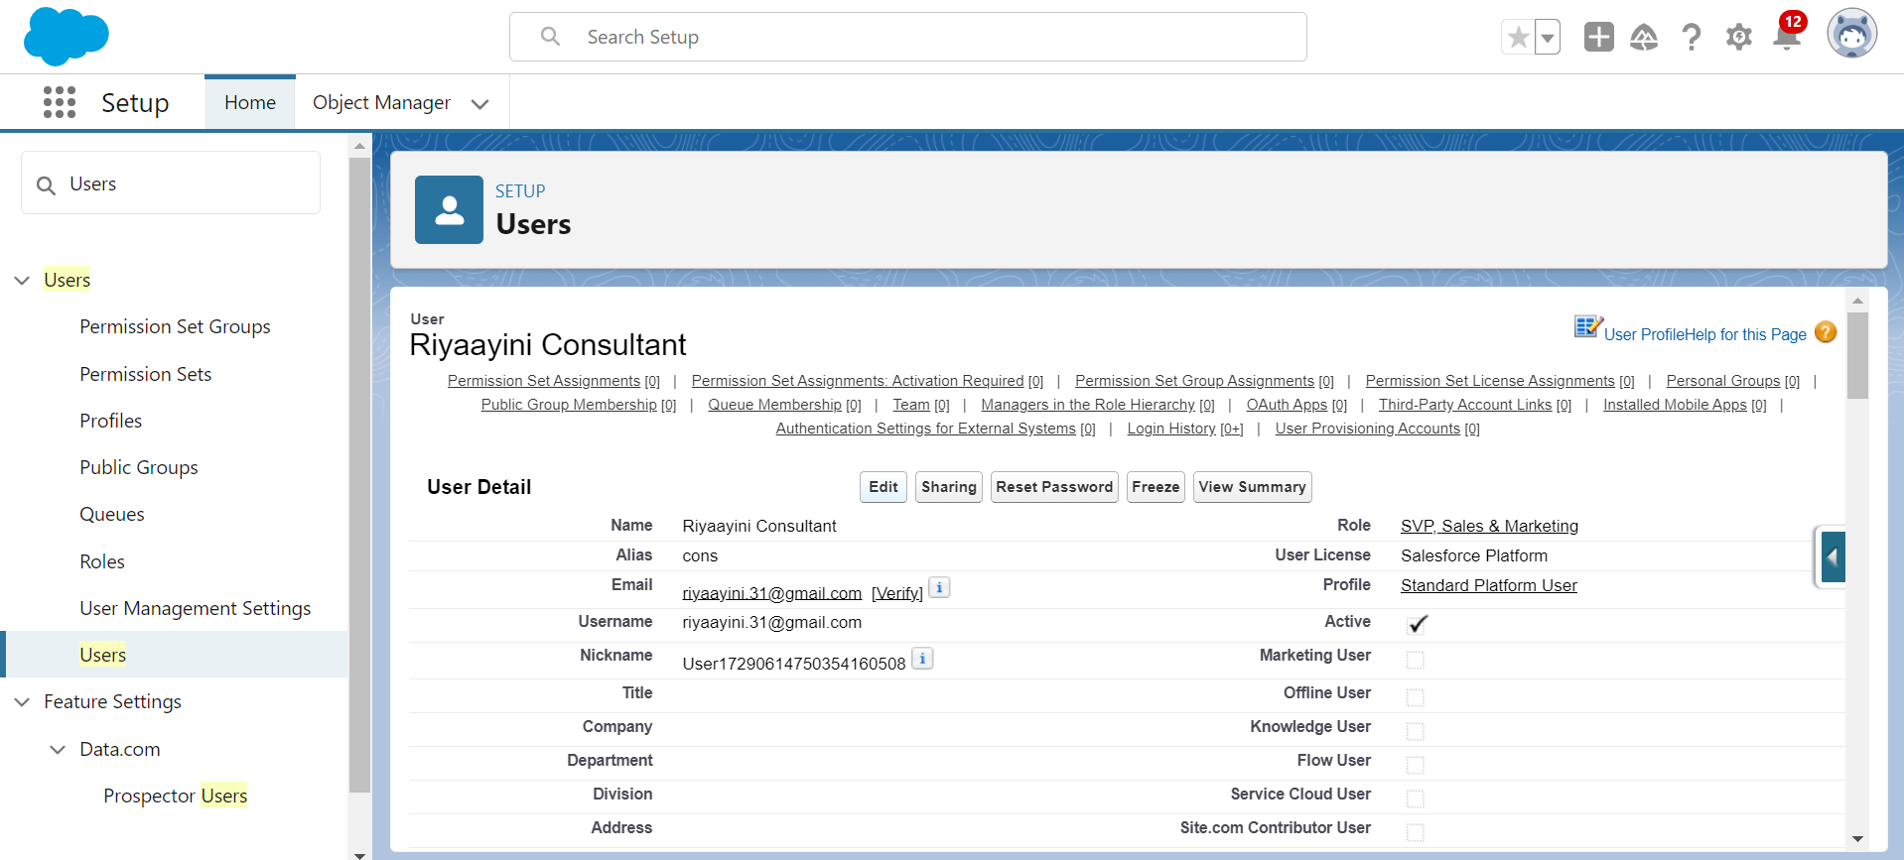

**Configure The User Settings:**

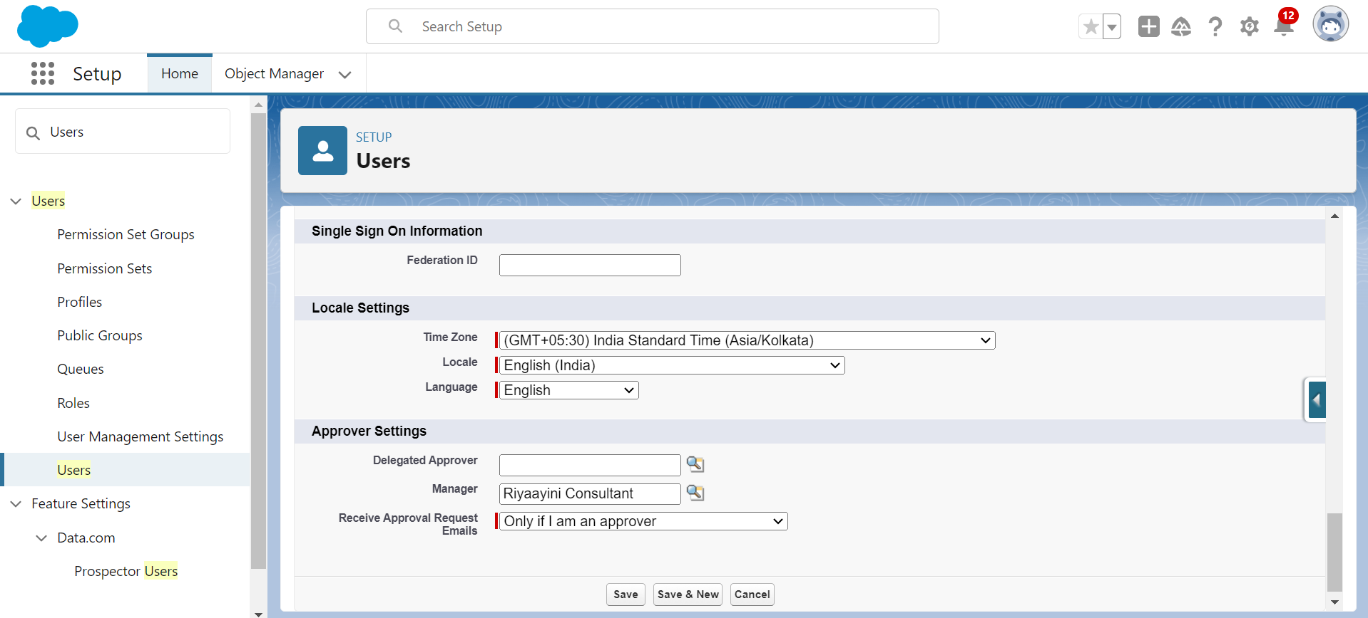

**Create an Approval Process for Property Object**

1. Create an Approval Process for the Property object to manage and automate the approval workflow.
2. Develop an Email Template to notify users when a property record is approved or rejected.
3. Configure the Approval Process by defining the steps, approval criteria, and email notifications, ensuring smooth and automated approval handling for the property records.

**Create an Email Template:**

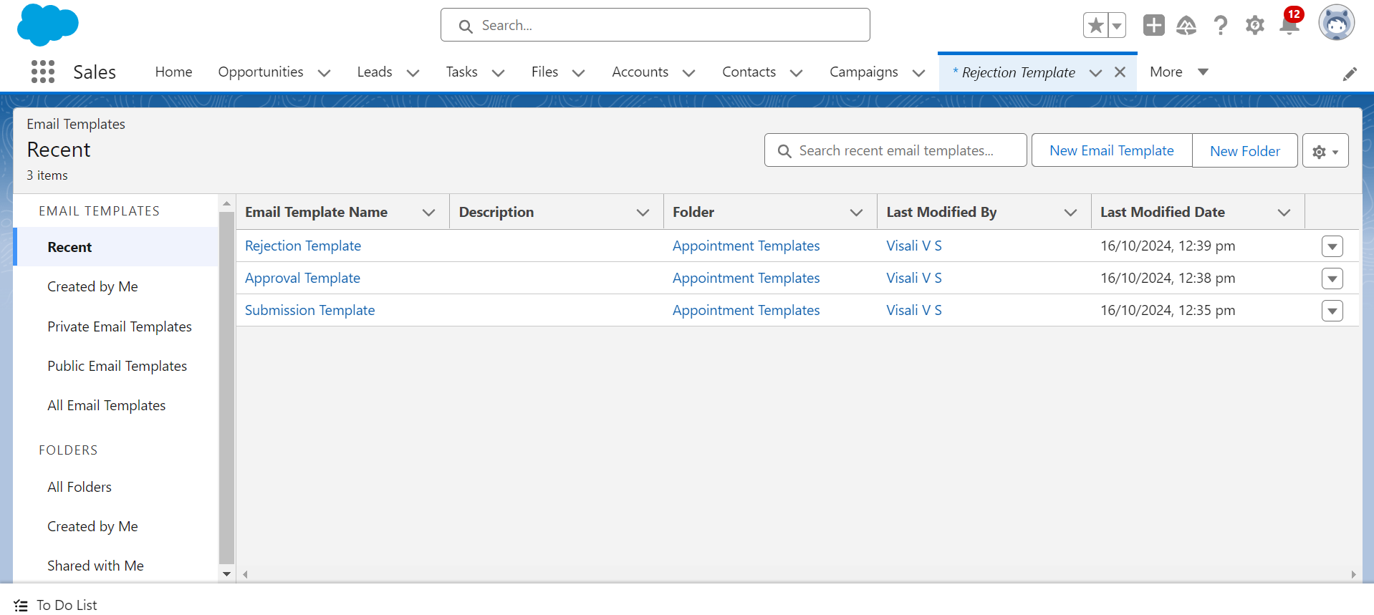

**Create An Approval Process:**

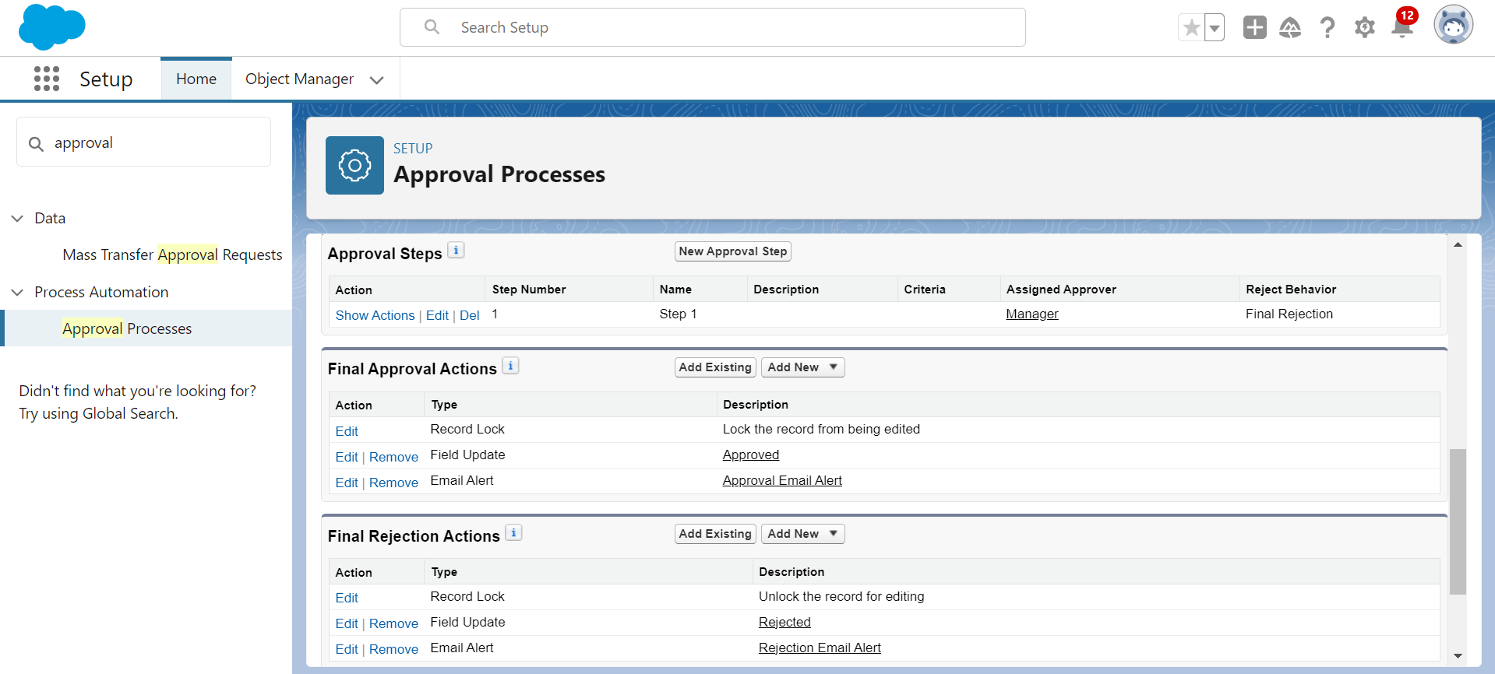

**Create a Record Triggered Flow**

1. Create a **Record-Triggered Flow** to automate actions based on record creation or updates.
2. Configure the **Start Element** to define when the flow should be triggered, such as when a record is created or updated.
3. Add an **Action Element** to perform tasks like updating a record, sending an email, or invoking another process based on the triggered event.

### Configure the Start Element

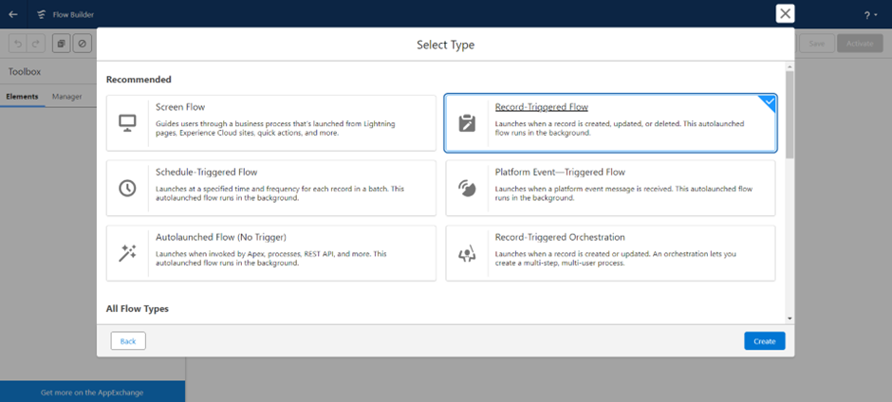

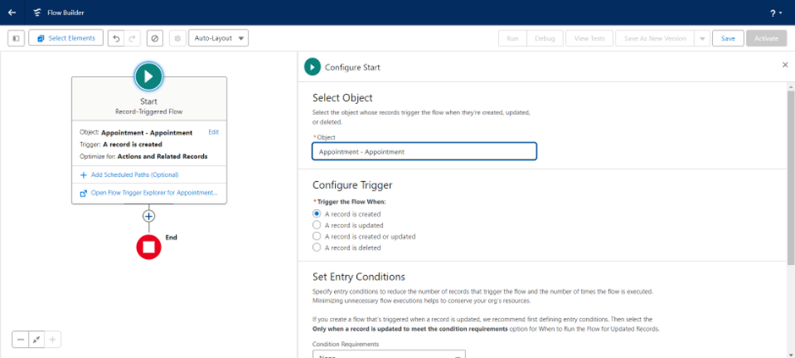

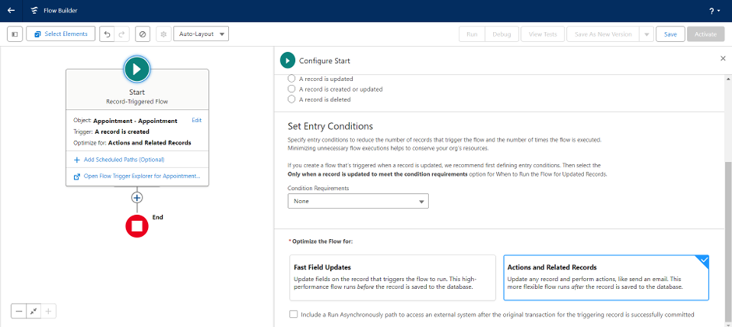

### Add an Action Element

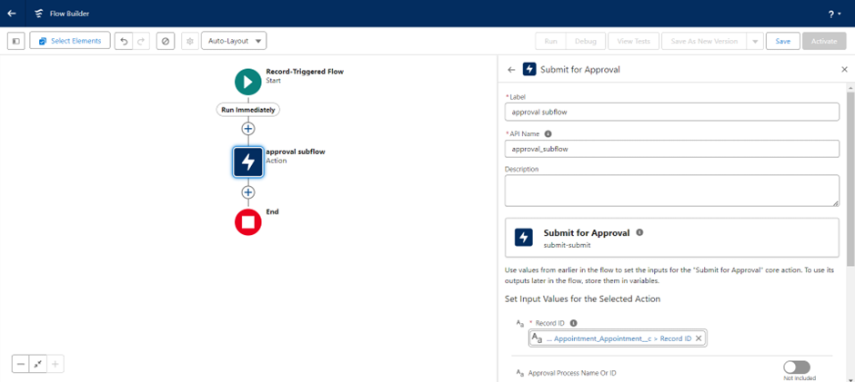

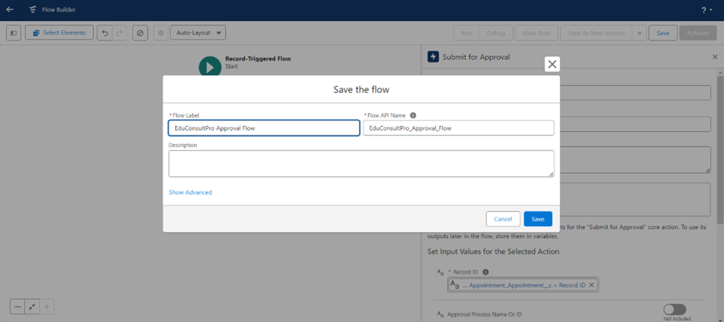

**Create a ScreenFlow for Existing Student to Book an Appointment**

1. Create a ScreenFlow for existing students to book an appointment.
2. Add a Screen Element to collect appointment details from the student.
3. Use a Get Records Element to retrieve the student’s existing information, such as their contact details or previous appointments.
4. Add another Screen Element to display appointment options or additional instructions.
5. Add a Decision Element to evaluate conditions, such as availability or eligibility for an appointment.
6. Add another Screen Element to confirm the student’s selection or collect further input.
7. Use a Get Records Element again to check the availability of consultants or time slots for the appointment.
8. Create an Appointment Record using the Create Records Element to store the appointment details.
9. Add a Screen Element to show confirmation of the booked appointment.
10. Add a SubFlow Element to invoke any other related flows, such as sending a confirmation email or updating related records.

**Add Screen Element**

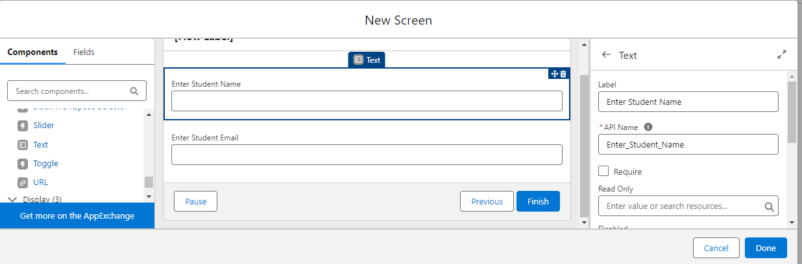

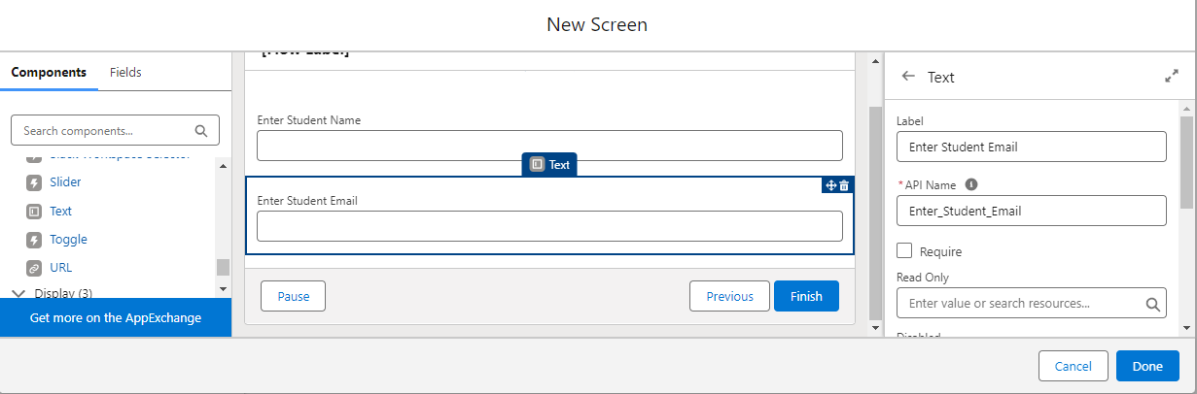

**Add GET Record Element**

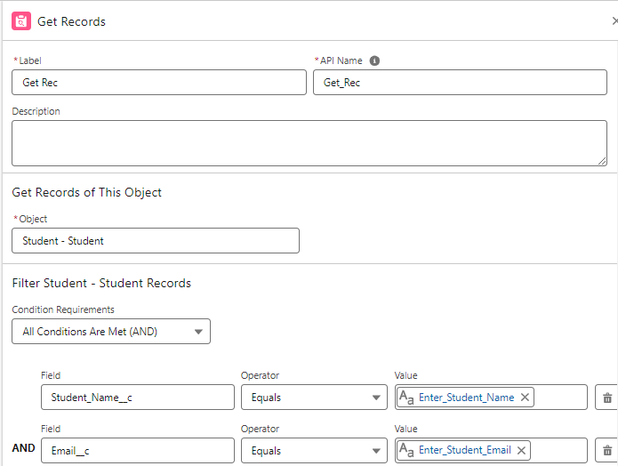

**Add Screen Element**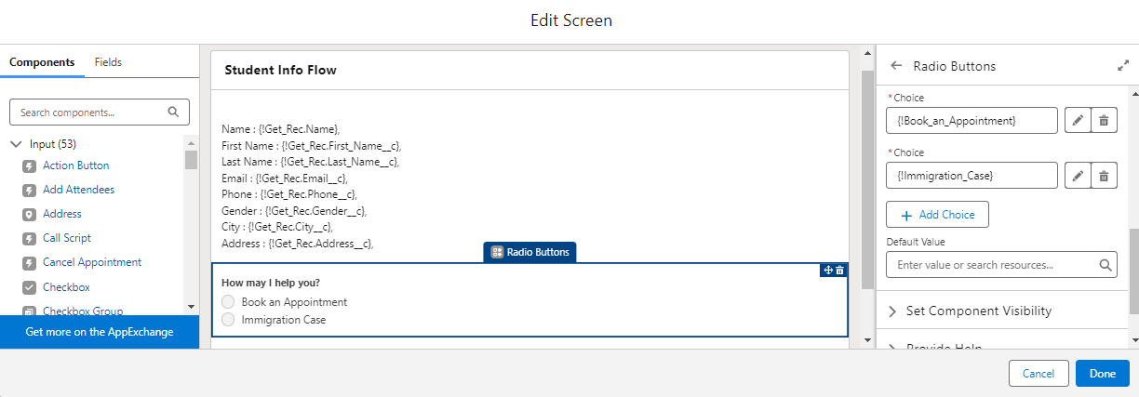

**Add Decision Element**

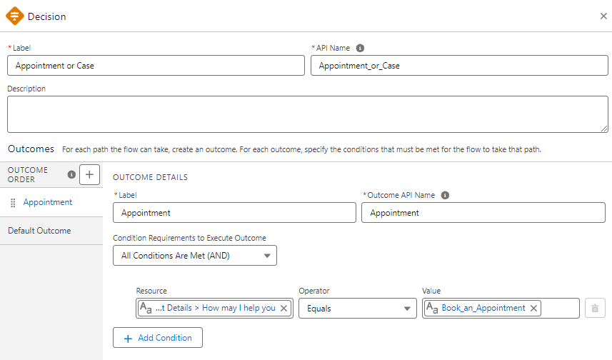

**Add Screen Element**

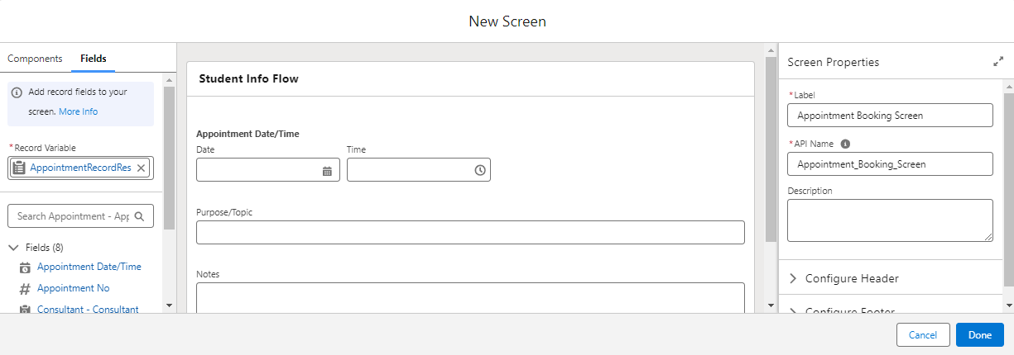

**Add GET Record Element**

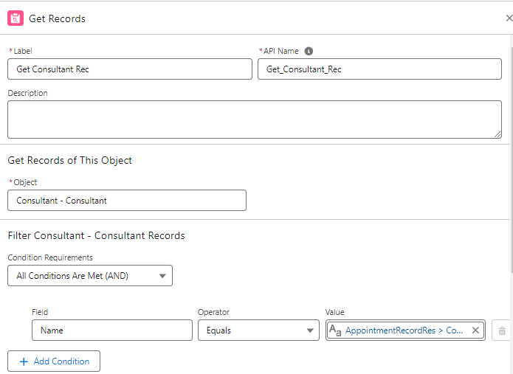

**Create Appointment Record using Create Records Element**

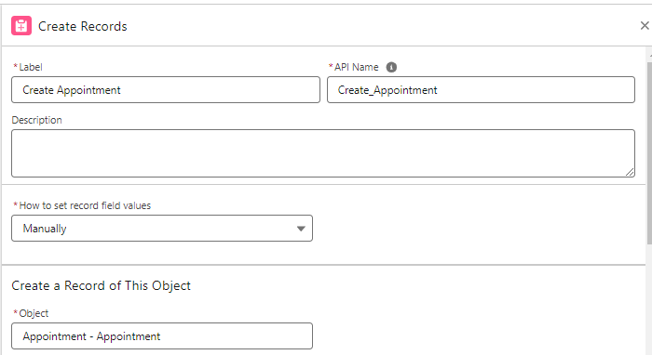

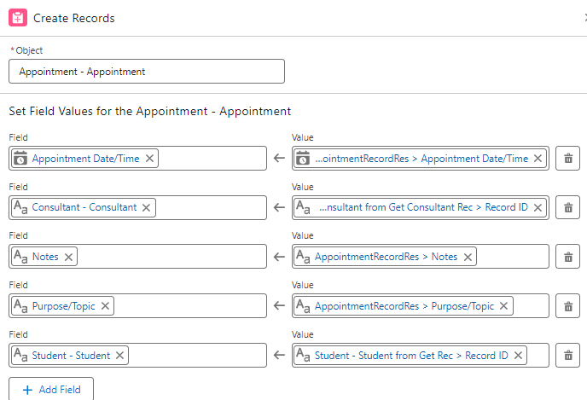

**Add Screen Element**

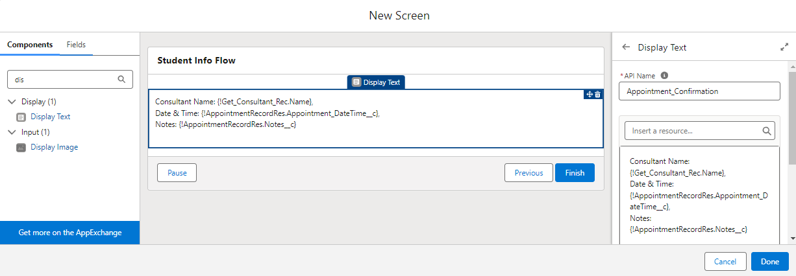

**Add an SubFlow Element**

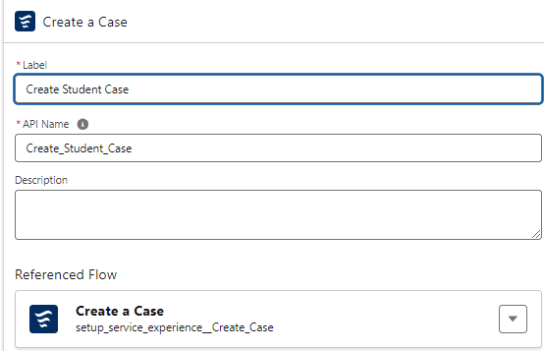

**Create A ScreenFlow To Combine All The Flows At One Place**

1. Create a ScreenFlow to combine all the flows into one central process.
2. Add a Screen Element to guide the user through the initial steps or provide instructions.
3. Add another Screen Element to display additional options or gather more information from the user.
4. Insert a Decision Element to evaluate conditions and determine the next steps based on user input or other criteria.
5. Add a SubFlow Element to invoke another flow for specific tasks, like booking an appointment or processing student data.
6. Add another SubFlow Element to invoke additional flows as needed, streamlining the overall process.

**Add Screen Element**

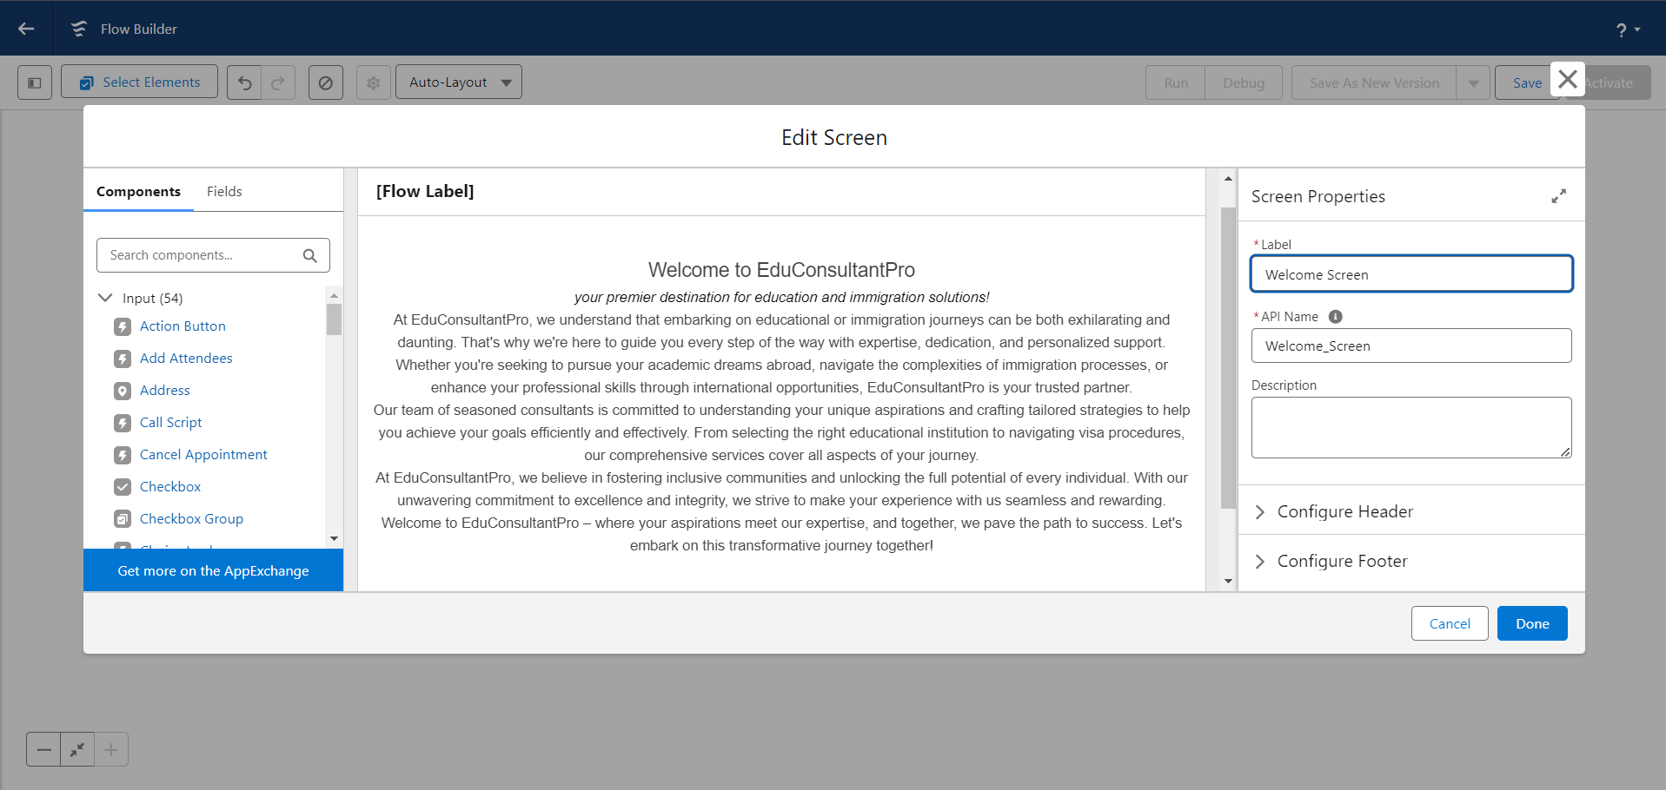

**Add Screen Element**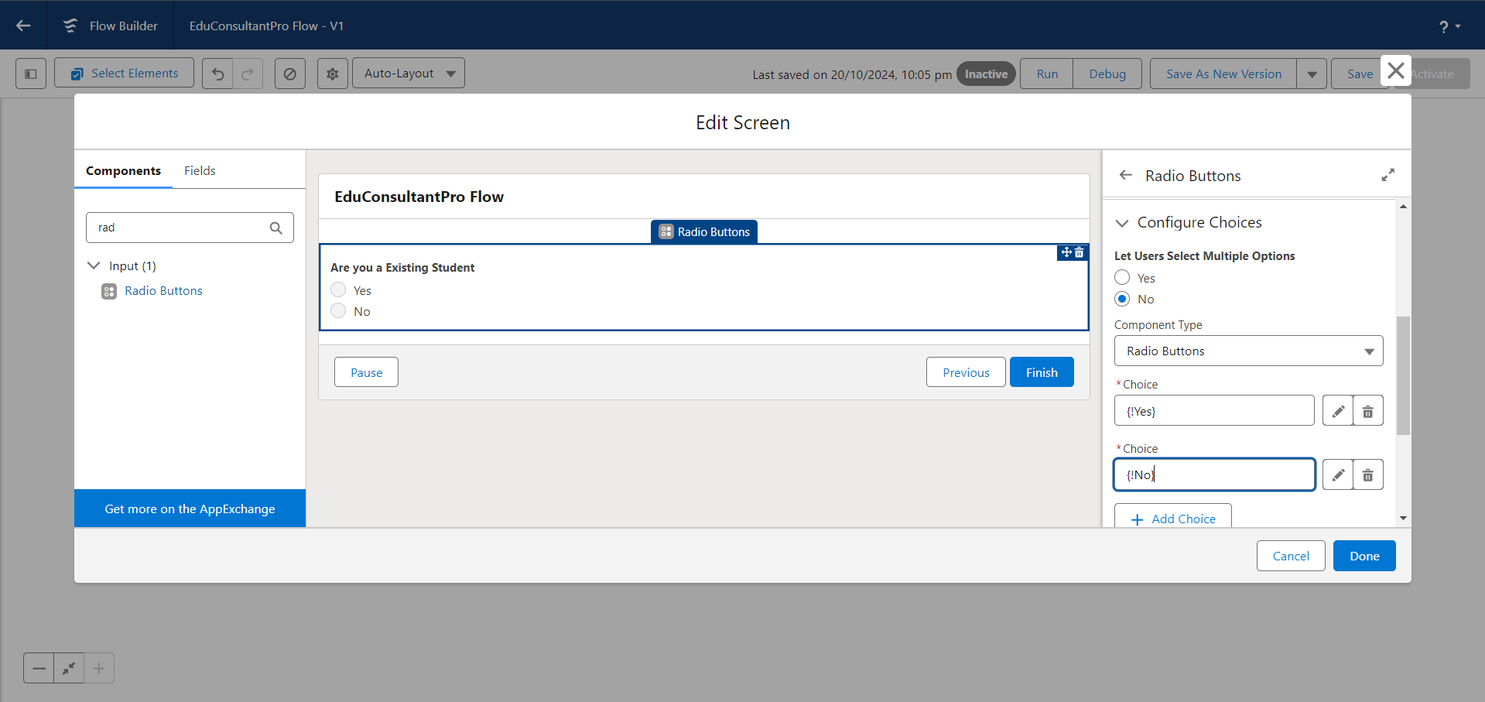

**Add Decision Element**

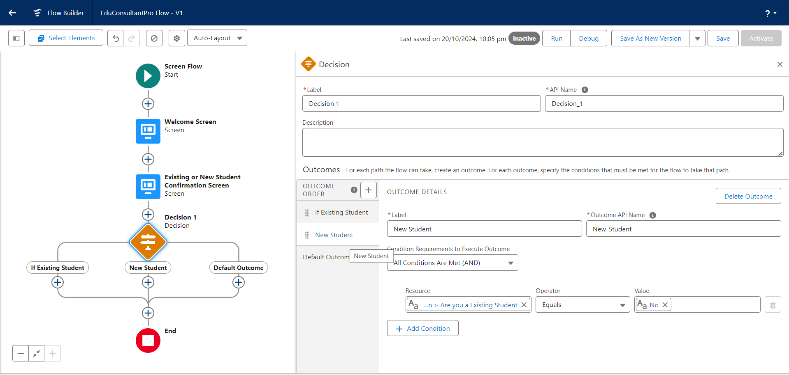

**Add an SubFlow Element**

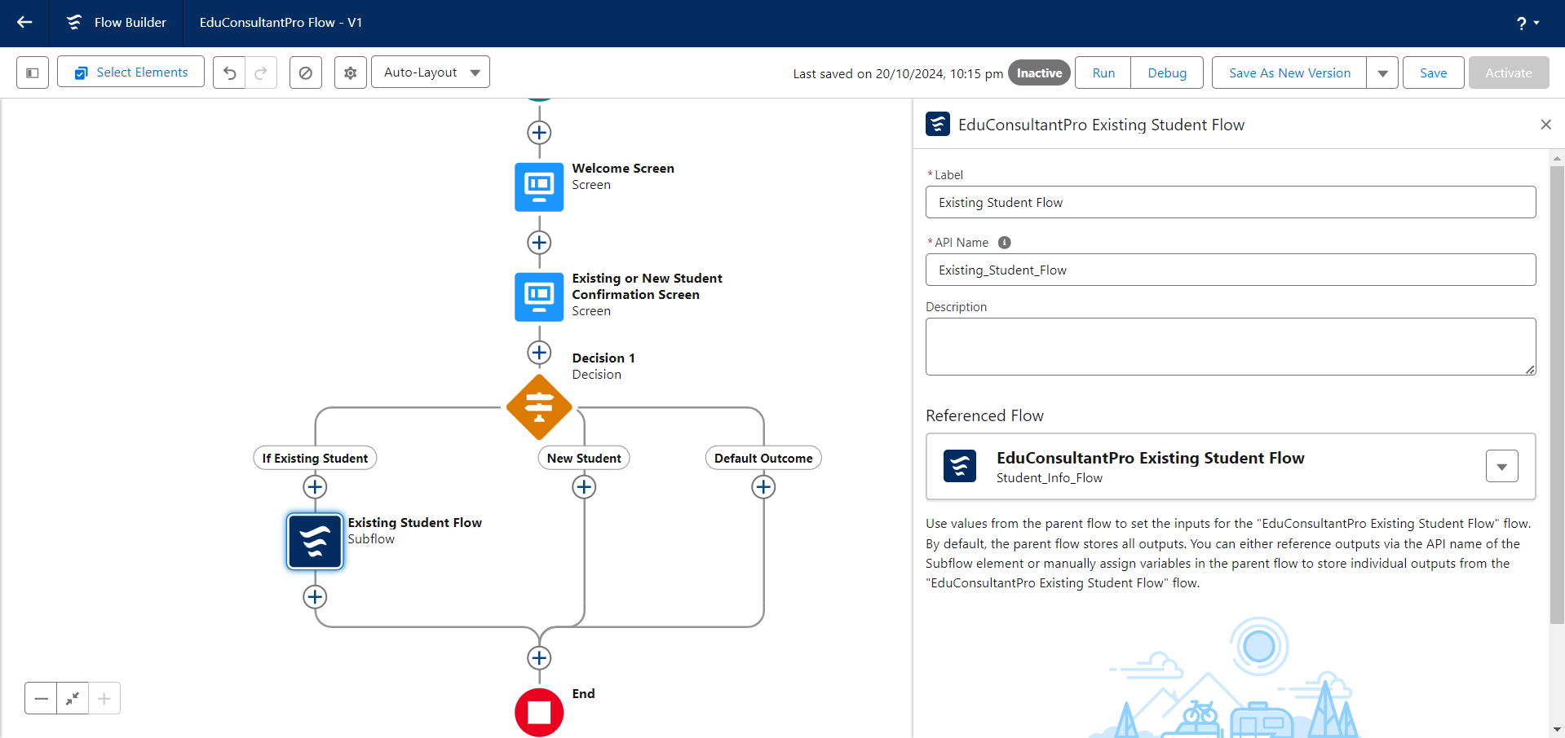

**Add an SubFlow Element**

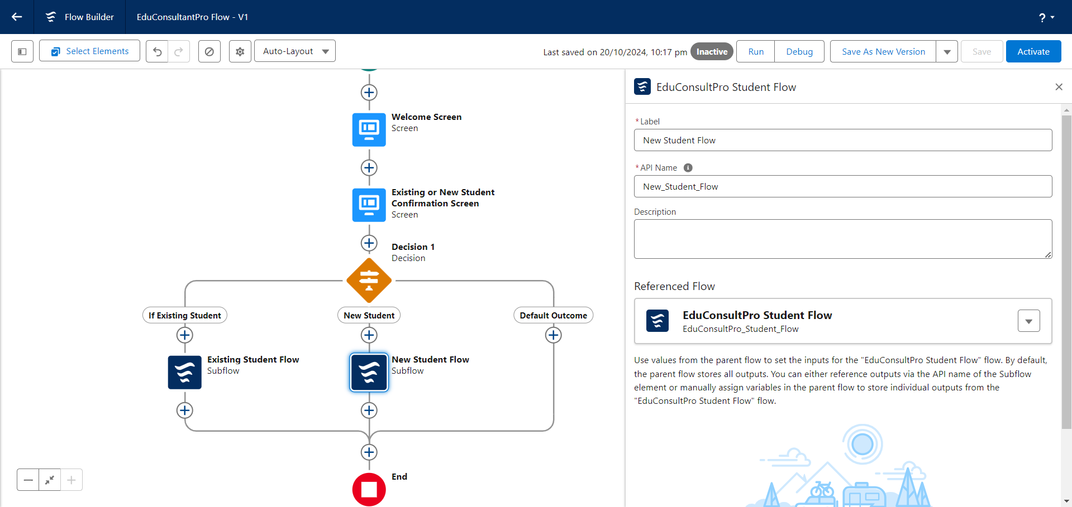

**Create a lightning app page**

1. Create a Lightning App Page to customize the layout and design of the application interface.
2. Add relevant components, such as record pages, lists, and charts, to the Lightning App Page to enhance user experience and functionality.

**Create a lightning app page**

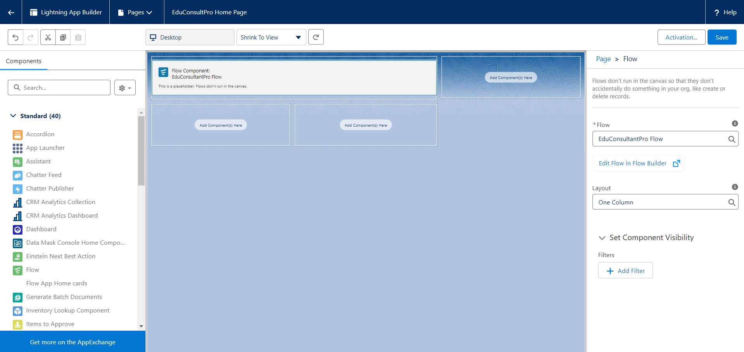

**CONCLUSION:**

* The project successfully streamlined the student admission process and improved case management for the EduConsultPro Institute.
* Salesforce features like ScreenFlows, Approval Processes, and Record-Triggered Flows were utilized to automate tasks and improve efficiency.
* Custom objects and relationships were created to organize student, course, and appointment data effectively.
* A centralized Lightning App was developed to provide easy access to critical information and manage workflows.
* The system improved communication and reduced manual effort, enhancing the user experience for both students and staff.
* Overall, the project optimized the institute's ability to manage student enrollments, appointments, and related processes.